UP TO 2 PHOTOS PERMITTED TO GIVE PARTNER IDENTITY.

ADD LOGO OF PARTNER INSTITUTION

DELETE THIS BOX

<Course title>

Faculty of <faculty>
School of <school>
<Name of collaborative partner>

DO YOU have any queries after reading this guide?

for COURSE queries please contact <insert generic COURSE email address>

This handbook sets out a range of information about your course and points to a number of other important documents to help support you through your studies at r<insert name of partner institution>.
The purpose of this handbook is to provide information about your course. It should be read in conjunction with the following:
- information that applies to all students on a CCCU course, bearing in mind that some will apply only to students studying in Canterbury: Your Essential Guide, which sets out general information relevant to all students at the University, and the Current Student webpages.
- Information relating to CCCU students at <insert name of the partner institution>: <insert partner web page>
- your Module Handbooks available on each module Blackboard.

This information is designed to support you throughout your studies. It is important to familiarise yourself with it.

Your
COURSE
Handbook

<name of collaborative Partner>
<collaborative partner email address>
<collaborative partner telephone number>

CANTERBURY CHRIST CHURCH UNVERSITY

i-zone@canterbury.ac.uk
01227 922222
Ask the iZone

Ask the iZone

CONTENTS
Graduate Attributes Statement 4
Welcome from the Course Director & <insert name of Partner> Course Director 5
Course Overview 5
Key Staff and Contact Details 5
How we will communicate with you 5
Key Dates and Timetabling 6
Special Events 6
Course Structure 7
Learning and Teaching 7
Assessment 8
Regulatory arrangements 9
Personal Academic Tutoring 10
Student Voice 10
IT support 11
Employability, Careers and Enterprise 11
External Examiner 12
Additional information 12
You may wish to cover: 12

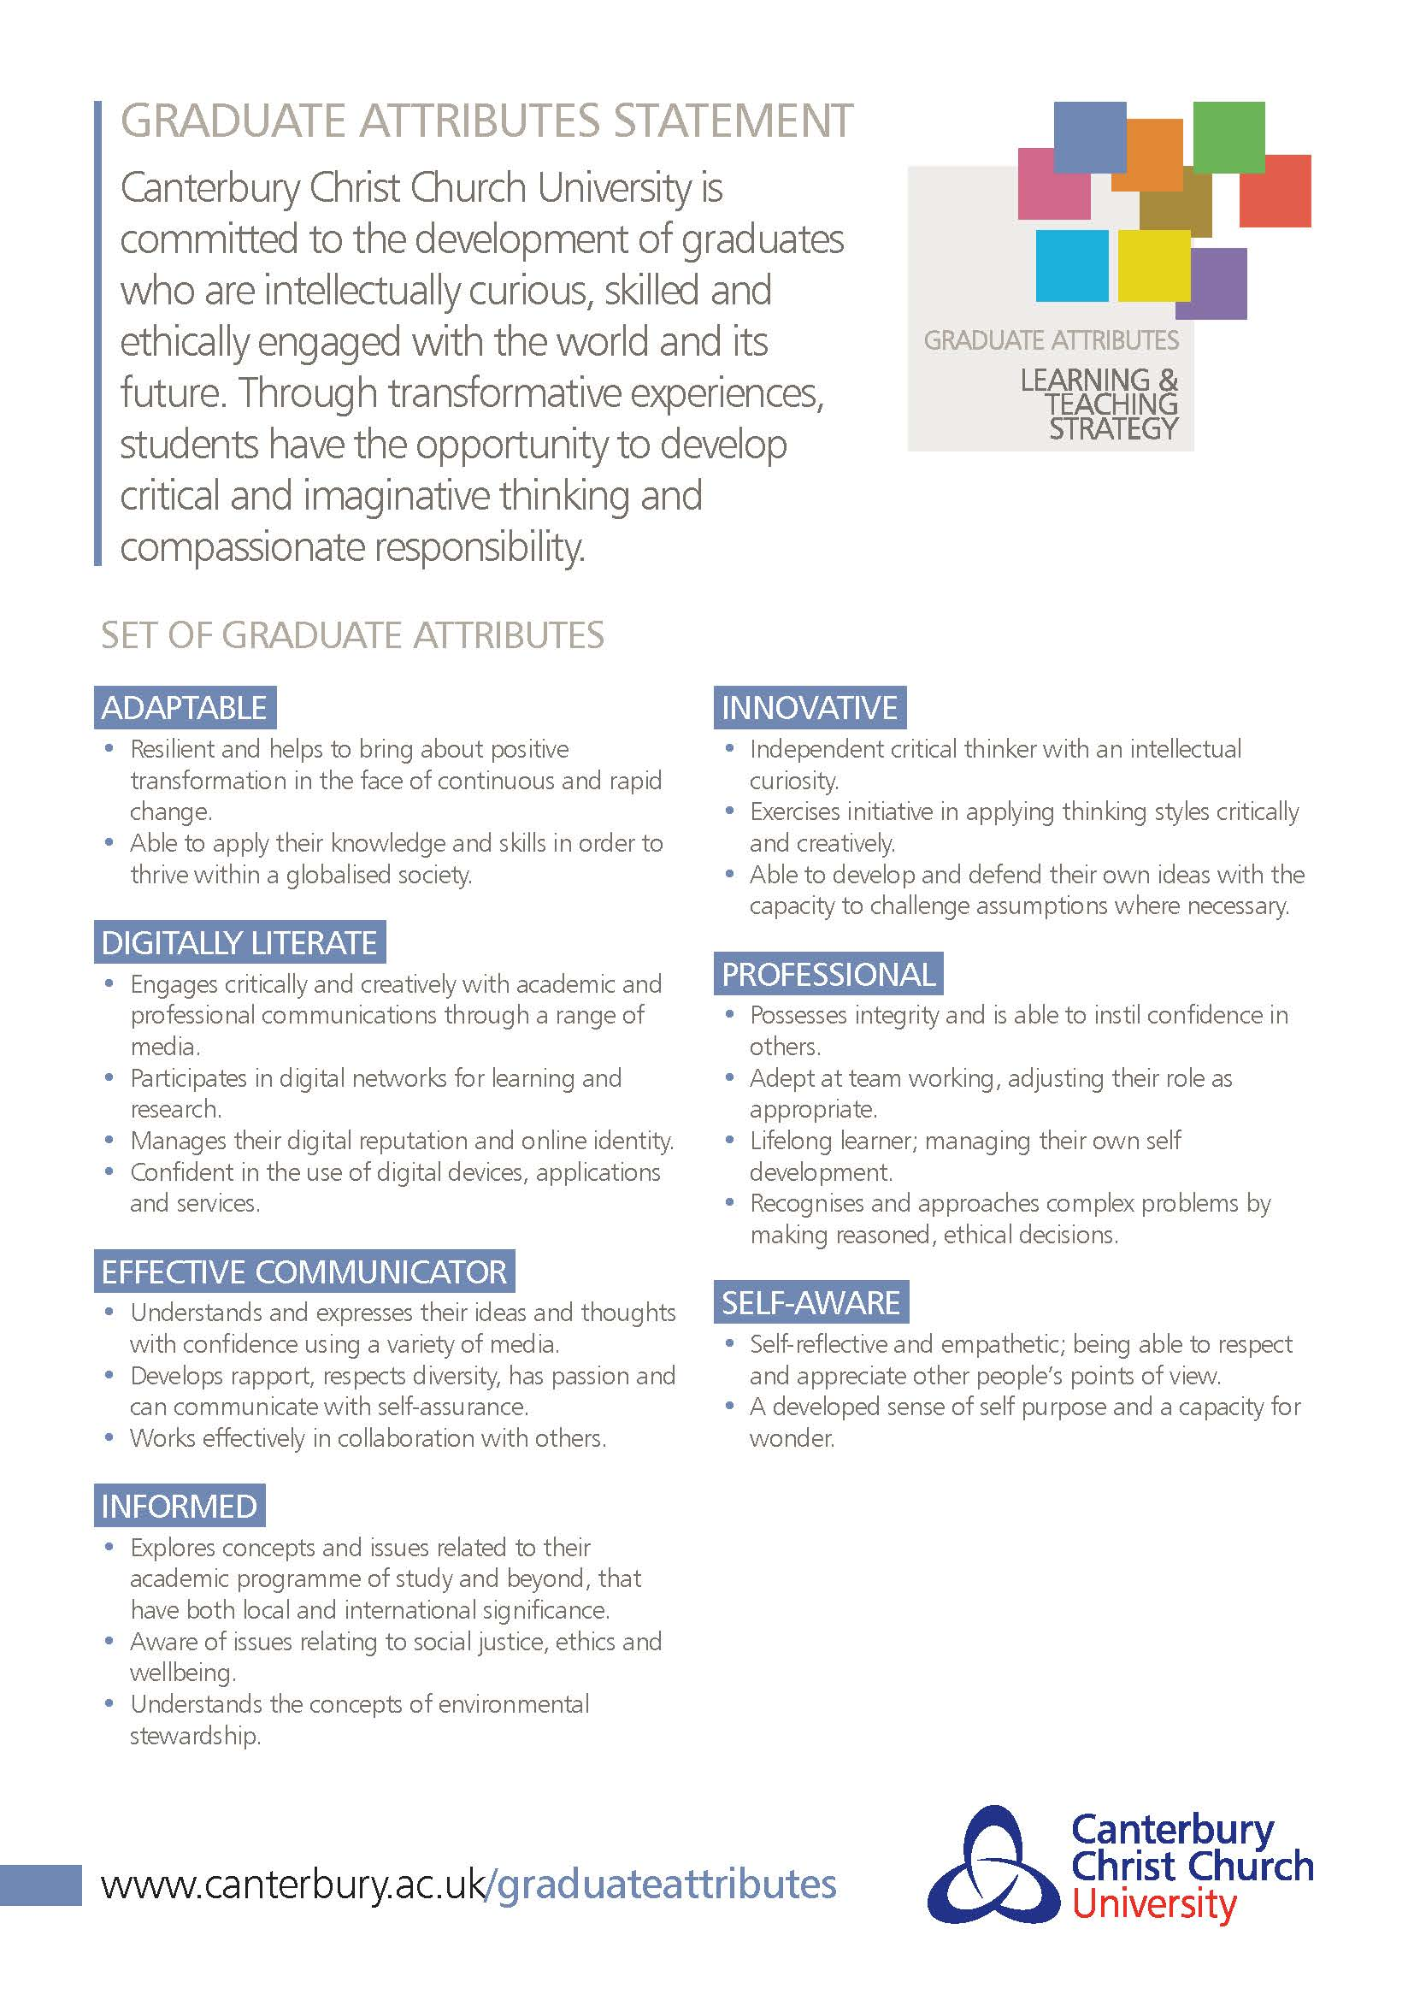
DELETE THIS BOX Note to staff: This template provides a series of headings that are required as part of the Student Course Handbook. Suggested areas are provided under each heading but these should be interpreted as minimum requirements only. Course Directors are free to add information, where relevant. Once you have finished updating the information in the handbook, please update the contents page above by clicking ‘update field, update entire table’.

Much of the information can and should be taken from the Course Specification as approved at course approval, but there is not a requirement for the Course Specification to be included in the Handbook. The Course Specification should be published on the Course Blackboard with a link provided to this as part of the Course Overview section below.

Please do not reproduce in this handbook any information that is subject to review, such as entire copies, sections or paraphrased versions of University regulations, policies, procedures and guidance. Instead, wherever possible, include a hyperlink to the relevant web document, to ensure students view the correct versions. Please check any web links you have added for currency each year to make sure they are still active.

For courses delivered solely at collaborative partners, an alternative picture may be used for the front page of the handbook and the partner’s logo may be added. All other information should remain identical to the front cover provided as part of the template including the Canterbury Christ Church University logo.

Welcome from the Course Director & <insert name of Partner> Course Director
<A short welcome to the course from the partner and CCCU Course Directors. Contextualise the course within the partner institution to create a sense of belonging beyond the course>

<Add a link to the partner institution, CCCU Faculty or School webpages>
Add a photo of the course team if possible>

Course Overview
<Include:
- Course duration and mode(s) of study
- Language of teaching and assessment, where not English
- Course aims
- Course learning outcomes
- Professional body accreditation (where applicable)
- Course structure diagram (to include stepping off points for alternative exit awards)
- Hyperlink to Part One of the Course Specification on Your Course Blackboard site>

Key Staff and Contact Details
<Add key course staff contacts (name, telephone number, e-mail address) for:
- partner institution course director
- CCCU course director
- partner administrator/s
- teaching team and personal academic tutors (partner’s and CCCU’s)
- Faculty student learning developer
- Careers and Enterprise careers@canterbury.ac.uk
- IT Services it-services@canterbury.ac.uk
- <add as appropriate>

This is an opportunity for students to put a face to a name, and get to know the academic experts for this course. Whenever possible, add brief biographies, photos, and links to internal staff web pages >

How we will communicate with you
We will contact you with important information and updates via your <insert which system is used, CCCU email or partner email> e-mail address, so please make sure you check your <insert> e-mails regularly.

<Add any course/School specific communication channels such as Facebook page, Instagram account, twitter handle etc>

Key Dates and Timetabling
<Add
- semester / trimester dates
- assessment period
- reassessment period

For courses delivered in line with the University calendars, copy and paste the official university calendar and add information to it if you wish. 2022/23 calendars can be found at https://www.canterbury.ac.uk/our-students/ug-current/academic-services/timetable-and-dates/university-dates-2022-23 >

Attendance at timetabled sessions (onsite or online) and engagement with your studies is a fundamental part of your learning experience. You must make yourself available to undertake all activities relating to your course. <Add info here if the partner institution has an attendance monitoring system.>

If you cannot attend a session for any reason, you should let your tutors and Personal Academic Tutor know.

Accessing your timetable
<add information on provision of students’ timetables here>

Special Events
As well as your taught sessions, there are special weeks within your timetable for focussed activities. The special weeks that apply to you will depend on your course and level of study.

<If certain weeks outlined below do not apply to this course please delete as appropriate>

Welcome Week
This week is targeted at all students starting or progressing onto a new course. It will familiarise you with the University and offer time to get to know students and tutors on your course. <add information as appropriate>.

Academic Development Week
This is a week dedicated to you advancing your learning through focussed activities and allowing you time to prepare for assignments and develop your academic skills. This is a vital opportunity for you and your Personal Academic Tutor to reflect on your academic progress so far and for you to get advice on the next steps you need to take to achieve your full potential. It is also a chance for you to access wider development opportunities around the University for example, in volunteering and peer mentoring. <add arrangements for the week>

Personal Development Week
This is a dedicated week for you to engage in focussed activities that will develop your wider skills, enhance your employability and prepare you for your future career. <add arrangements for the week>

Reassessment Week
This is when formal reassessment for modules will take place where applicable, as per the calendar above (for more information about reassessment, see Your Guide to Undergraduate/Postgraduate Assessment and Award Processes).

<UK partners only: Further information on events, activities and support offered during each of these weeks will be published on the CCCU Student Blog throughout the year.>

<add partner institution’s own events and activities here>

Course Structure
<Provide the detail of all modules, core and optional, per semester/trimester. Provide the list of option choices at all stages of the course, making it clear how module options are selected.

<Clearly set out any Pre-requisites (a module that must be taken to access another module and Co-requisites (a module that must be taken alongside another module)>

<Inform students where more detailed module information can be found via the Module Handbooks on Blackboard >

Learning and Teaching

Learning and teaching activities
<Set out briefly the types of classes and activities this course contains, e.g.
- lectures, which are attended by all students on the module at the same time
- seminars, workshops, etc. where a smaller group of students are required to attend a specific session
- rehearsals, practicals, etc. where students work together to deliver a project
- …>
<You may want to say briefly why this particular approach to learning and teaching has been adopted for this course and outline a learning plan which clearly demonstrates how face-to-face activities complement online learning (synchronous or asynchronous) Blackboard or other >

Learning Technologies
Your tutors will be using a range of learning technologies to support your learning. To become more familiar with the use of these technologies see the IT Services website.

<Set out briefly the range of learning technologies used for this course and how they will be used:
- e.g. ReCap, Blackboard, PebblePad
- Discipline-specific softwares and technologies
- Partner institution specific VLE and technologies where relevant>

Placement / Year in Industry <if applicable>
<Provide students with the basic information they will need; if you have separate guidance on Placement / Year In Industry please link to it here>

Self-study and independent learning
As well as participating in live sessions, you are expected to undertake self-study and learn independently
<briefly set out the expectations for self-study and independent learning for this course>

Developing your skills
<briefly set out the partner institution support available and link to study skills pages>
https://www.canterbury.ac.uk/learning-skills-hub.

<Add more sub-sections as needed>
…

<Where there is a common approach across the School, feel free to have similar text in this section>

Assessment
<provide very brief overview of how students will be assessed, in line with the assessments in the approved course specification>

Referencing system
<If the same referencing system is used throughout all modules on the course, please insert information about it here, with links to Cite Them Right>

Assessment criteria
<if there is course level assessment criteria grid, paste it here, or say where the assessment grids can be found e.g. the Module Handbooks on Blackboard >

<include a schedule of assessment deadline dates, times and feedback dates, or a link to where students can find this information on Blackboard. Please note that Your Essential Guide provides details of the Timely Feedback Policy so please clarify if your course has gained exemption from this policy>

How to submit your assessments
Most assessments should be submitted through TurnItIn, the University’s e-submission service. TurnItIn allows you to check your assessment to avoid plagiarism. Find out how to submit to Turnitin here.
<If your course does not use TurnItIn explain how assessments will be submitted>

Learn more about the University’s computing systems and learning technologies here. This covers everything from logging in and getting started to using Blackboard and Turnitin.
<add information about partner institution’s own learning technologies as applicable>

Self-checking your assessments before you submit
For coursework submitted via TurnItIn, you will be able to submit a draft of your work to check whether you are at risk of having plagiarised. The module Blackboard will offer a draft Turnitin submission point to allow you to do so. <amend this section if you do not use coursework submitted via Turnitin>

Your Guide to Assessment and Awards processes
To learn more about University assessment and award processes these guides provide key information about how assessment is carried out, the formal steps involved in making a final award, and the University’s Regulation and Credit Framework that governs academic awards.

Feedback
You will receive your feedback on TurnItIn and via other means <amend this section if you use other additional means for return of feedback>. The University has a 15-day turnaround time for providing feedback, with the exception of a few assessments (such as examination and independent studies).
<If you have a 15-day timely feedback exemption state specifically what this means in terms of when students will receive feedback>

Once you have access to your marked work you should take time to read through/listen to comments, look at the highlighted assessment grid, and reflect on the guidance in the comments in Turnitin or Pebblepad. You can then consider what aspects of the feedback can feed into your own targets and actions to develop your academic work. Find out more about using your feedback here.

Preparing for Reassessment
If you have not passed assessment and have reassessment contact your Personal Academic Tutor or Course Director and ask for a tutorial to support you to re-engage with assessment or what you have to do to resubmit for reassessment or retake an exam. Find out more about how we can support you with your reassessment here.

Results
Your final results will only be confirmed after the meeting of the Board of Examiners. You will get your final results via MyRecord. <if your course uses a different method for results outline it here>

Contact your tutor if you have any questions about how, when or where to submit your assessments.

Regulatory arrangements
This course operates within the Regulation and Credit Framework for the Conferment of Awards, which provides the regulatory arrangements for the University’s courses.

This sets out how your degree classification will be calculated and the requirements for obtaining your award. The regulations are explained in more detail in Your Guides to Assessment and Award Processes.

This course has some special requirements because it is also regulated by a Professional Regulatory or Statutory Body (PSRB). Briefly state the body involved and add a hyperlink to the specific course Special Regulations PDF document> Delete if this course does not have PSRB involvement or Special Regulations.>

<On successfully graduating from this course, you will be granted membership of …..>
Delete this if the course does not confer membership of a professional organisation.

Personal Academic Tutoring
Every student is allocated a key named member of academic staff from their course of study, called a Personal Academic Tutor (PAT).
Your PAT is there to provide you with academic support helping you to identify the academic skills you need to develop in order to succeed in your studies. If you are a combined honours student, you may have two PATs.

PATs will provide regular scheduled appointments to meet with their tutees either individually or in groups; these will take place at least three times per year. To find out who your Personal Academic Tutor is please contact your Course Team.

<If the course uses Peer Assisted Learning (PAL) and/or peer mentoring, add a line about it here>

Student Voice
If you want to be more active and represent your course and peers, there are several ways you can do so. For example, you can become a Student Rep for your course or you want to be more active and represent your course and peers, there are several ways you can do so. For example, you can become a Student Rep for your course or <partner institution’s name> and also get involved in the Students' Union at <partner institution’s name>.

Your course will run an election for course reps at the beginning of each academic year. <Briefly set out the election process for this course if you wish>

School and Faculty reps are elected via the Students’ Union. To get involved head to the SU website where you can find details on how to stand for school/faculty rep and even Union Council: ccsu.co.uk

The University is keen to hear your views on your course and course delivery, and one of the ways this takes place is through Student-Staff Liaison Meetings. Meetings normally take place once per semester/trimester/term, and provide a chance for you to feedback course issues to allow staff to improve the quality of the student experience. The elected student representative(s) will attend these meetings, to raise the views of fellow students and report back to their peer group on the outcomes. Matters relating to individual students are not discussed at SSLMs. <Add in any other partner-specific student voice mechanisms here>

As a student rep you are also involved in representing your peers at academic meetings to improve the experience of all students, such as boards of study, annual monitoring, and course approval or review. Your Course Team will let you know when there are opportunities to get involved.

IT support
The IT department offers a range of support services to help you with your studies. You can access IT services by visiting www.canterbury.ac.uk/it. There you will find:
- Email and calendaring
- IT training and drop-ins
- Free and discounted software (including Microsoft Office)
- How to take free official certified Microsoft exams
- Information on printing, OneDrive, Wi-Fi, and where to find a PC
- Plus much more…

Employability, Careers and Enterprise
All courses at Christ Church are aligned to our Future 360 Framework for Developing Enterprising, Professional Graduates (2019-2024).

To enhance your employability the Careers and Enterprise Hub provides a wide range of services and activities supporting this framework including:
- 1:1 careers guidance appointments
- Online resources i.e. AI and other tools to support your career development and job success
- Advice on writing CVs, personal statements and cover letters
- Regular online and on-campus workshops and events including job fairs
- Courses leading to Microsoft accreditation etc.
- Bursaries to assist with travel and other expenses related to gaining work experience
- Volunteering and part-time job opportunities with Unitemps
- Advice on starting your own business, enterprise workshops and the chance to attract seed money for your business idea
- And exclusively for final year students the opportunity to enrol in our exciting GradForce programme designed to fast track you into local graduate level employment
- Plus much more…
Visit: https://www.canterbury.ac.uk/current-students/careers-and-volunteering/careers-and-jobs/careers-and-enterprise-hub or email: careers@canterbury.ac.uk

External Examiner
The University appoints External Examiners to act as an independent check on the academic standards of each module and the overall award. This is in line with the QAA UK Quality Code and part of the University’s approach to assuring and enhancing academic quality for all of its academic provision.

External Examiners are drawn from higher education providers and industry. External Examiners are appointed by the University through a formal appointments process which assesses each External Examiner’s qualifications and experience within their subject specialism to confirm their suitability for the role. External Examiners are independent of the University. The University operates two-types of External Examiners, those which are subject specialists and appointed to individual modules, and those which are appointed to Progression and Award Boards and make recommendations about progression and award for your course.

At some point during your course, you might be asked to meet the External Examiner(s). This meeting will be to allow the External Examiner to gather information on the quality and standards of the modules/course. Individual performance will not be assessed at this meeting and External Examiners do not consider issues regarding individual assessment outcomes. The External Examiner for your modules/award submits an annual report, which can be made available to students upon request.

Additional information
<you are welcome to add information which has not been included in this template so far; simply replace the heading above with your desired heading(s)>

You may wish to cover:
- Any applicable Professional Body relationships and requirements
- Any applicable Fitness to Practise policy (e.g. Faculty specific)
- Collaborative Partner details, where appropriate
- Placement requirements/opportunities, where appropriate
- Study Abroad, Exchange opportunities, where appropriate
- Extra-curricular activities/societies to help with belonging and community building for this course
- Things staff expect students to do which are outside the modules or course
- Academic essay writing guidance specific to the course (or a link to this)
- Examples of how student feedback has informed the course’s development
- Course specific learning resources guide

The above list is not exhaustive and additional information may be added.
Note to staff
Please note that students, other than combined honours, should not be provided with multiple course handbooks. This template and Your Essential Guide have been designed to enable all necessary course-level information to be included in a single document. As indicated above, additional sections can be added to this handbook. The only exception is where a course handbook is provided by the university and a collaborative partner provides a more localised handbook containing additional information specifically about the course delivery at the collaborative partner.

DELETE THIS BOX

