



Programme title text   
to be placed here

Faculty of <faculty>

School of <school>

**Canterbury**

[i-zone@canterbury.ac.uk](mailto:i-zone@canterbury.ac.uk)

01227 782222

**DELETE WHERE APPROPRIATE**

**BROADSTAIRS**

[i-zonebroadstairs@canterbury.ac.uk](mailto:i-zonebroadstairs@canterbury.ac.uk)

01843 609888

**If you find that you have any queries after reading this guide, please contact either your Program­me Director (for programme specific queries) or the i-zone for any other queries:**

This handbook sets out a range of information and, where applicable, points to a number of other important documents to help support you through your studies at the University.

The purpose of this handbook is to provide information about your programme of study. This should be read in conjunction with ‘My Essential Information’, which sets out general information relevant to all students at the University.

This information is designed to support you throughout your studies and it is important to familiarise yourself with all the contents of both this handbook and ‘My Essential Information’.

**Your**

**Programme**

**Handbook**

If you have any suggestions for how this handbook may be improved for future students,   
please email your suggestion to: [quality@canterbury.ac.uk](mailto:quality@canterbury.ac.uk)

**MEDWAY**

[i-zonemedway@canterbury.ac.uk](mailto:i-zonemedway@canterbury.ac.uk)

01634 894444

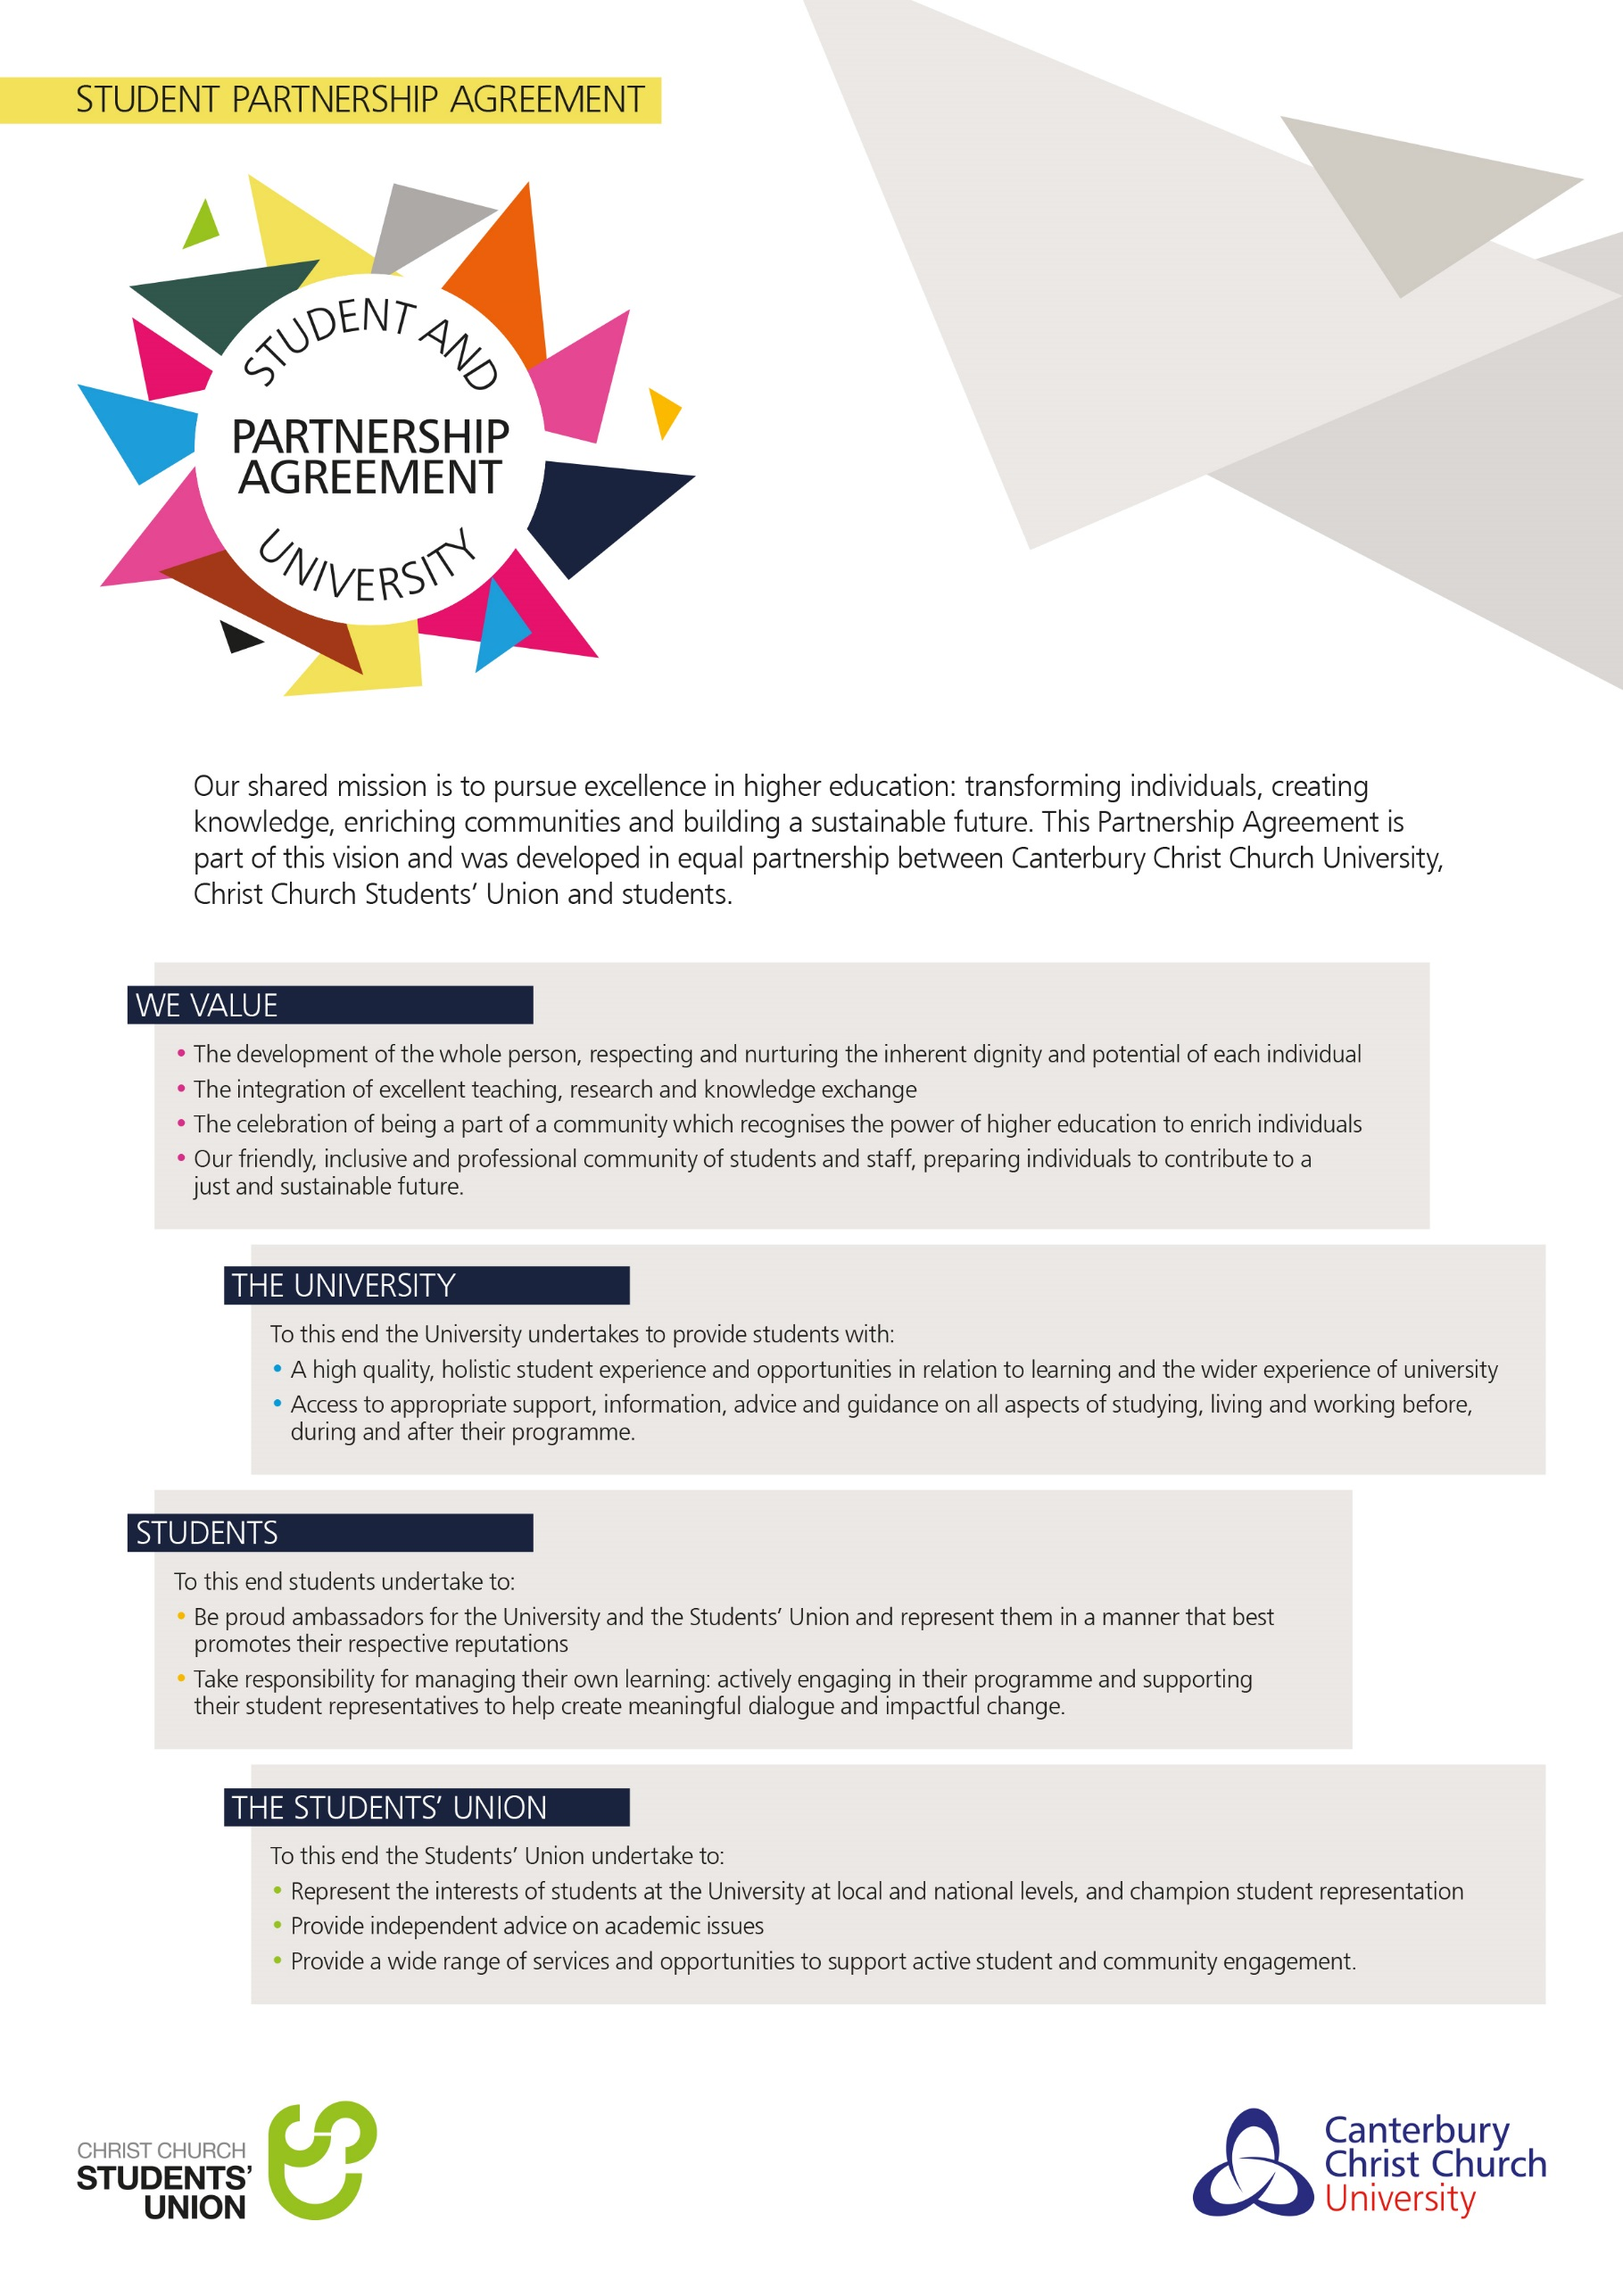

**Table of Contents**

**Type chapter title (level 1)1**

Type chapter title (level 2)2

Type chapter title (level 3)3

**Type chapter title (level 1)4**

Type chapter title (level 2)5

Type chapter title (level 3)6

This template provides a series of headings that are required as part of the Student Programme Handbook. Suggested areas are provided under each heading but these should be interpreted as minimum requirements only. Programme Directors are free to add additional information, where relevant.

Much of the information can and should be taken from the Programme Specification as approved at validation, however there is no longer a requirement for Part One of the Programme Specification to be included in the Handbook. Rather the Part Ones will be published on the University website and a link should be provided to this as part of the Programme Overview.

Please do not reproduce in this handbook any information that is subject to review, such as entire copies, sections or paraphrased versions of University policies, procedures and guidance. Instead wherever possible include a hyperlink to the relevant web document, to ensure students view the correct versions. Please check web links for currency each year to make sure they are still active.

**DELETE THIS BOX**

**Welcome from the**

**Programme Director**

<insert a short welcome to the programme from the Programme Director>

# programme overview

<To include:

* Programme duration and modes of study
* Language of study, where not English
* Programme aims
* Programme learning outcomes
* Professional body accreditation (where applicable)
* Programme structure diagram (to include stepping off points for alternative exit awards)
* Web link to Part One of the Programme Specification>

# Key STAFF AND CONTACT DETAILS

<insert key programme staff contacts (name, telephone number, e-mail address) for: programme director, administrator, and personal tutors>

# Key Dates and Timetabling

<insert term dates, examination period, and resit period etc. - for GMS programmes the dates can be copied and pasted from the GMS Supplementary Handbook>

<include information on how a student accesses their timetable – the following standard text could be used, where relevant>

ONLY APPLICABLE FOR PROGRAMMES WITH INDIVIDUAL   
STUDENT TIMETABLES - DELETE THIS SECTION IF NOT RELEVANT

Your academic timetable is available to view at any time via the ‘University Calendar’ tab on the online student portal.

*New students:* Initially this will be a *provisional* timetable, but once you’ve chosen your module options you will be able to see exactly where and when each of your lectures, seminars, practicals and other course-related activities for the forthcoming term are due to take place. In your first term, this will include all possible sessions you could attend, in case you end up swapping groups.

*Continuing students:*Prior to the start of the academic year, you will receive access to the timetable for the full autumn term, to help you manage your work/life balance.

‘University Calendar’ displays your next two programme-related appointments. Any changes or cancellations will be reflected here, so please take time to review your University Calendar regularly. To access your *full* calendar (to which you can add other activities personal to you), simply click on an appointment or the ‘My calendar’ link.

A ‘lite’ version of My University Calendar is available via the University Calendar tab on the Canterbury Christ Church mobile app.

Additionally, you can visit OnTime (the timetabling and rooming section of the CCCU website at <https://ontime.canterbury.ac.uk/>), select ‘View timetables’ and then choose the module or programme and dates you want to view. (If you see a choice of tabs, make sure you click on 2016/17.) Please be aware that changes or cancellations can occasionally occur, so check back regularly.

Timetable information may also be posted by your programme team via the Virtual Learning Environment.

If you have any issues with your personalised timetable, please report them to the i-zone. The Timetabling and Rooming Office aims to resolve queries in three working days.

# Modules

<module outlines may be included in this handbook, or in a separate module guide document which should not replicate this guide>

<include a summary of option choices at all stages of the programme, making it clear how module options are selected. Pre-requisites for option modules must be clearly communicated>

# Teaching and Learning

<explain the programme’s approaches to teaching and learning>

# Assessment

<provide an overview of how students will be assessed>

<include a schedule of assessment deadlines and feedback dates or a link to where students can find this information – please note that ‘My Essential Information’ provides details of the Timely Feedback Policy so please clarify if your programme has gained exemption from this policy >

<include guidance on academic referencing>

<insert where and how work should be submitted e.g. through a Turnitin assignment point located on Blackboard or to a designated office>

<include the assessment criteria or a link to where students will find this>

# Tutorials / Personal Academic Tutoring

<insert tutorial availability and information about personal tutoring>

# Regulatory arrangements

This programme operates within the Regulation and Credit Framework for the Conferment of Awards which provides the regulatory arrangements for the University’s programmes. This sets out information such as how your degree classification will be calculated and the requirements for obtaining your award. You can access it here: [www.canterbury.ac.uk/handbook/policies-procedures](http://www.canterbury.ac.uk/handbook/policies-procedures)

<if a Scheme (e.g. General Modular Scheme) or Special Regulations have been formally approved for this programme, please add a [hyperlink](http://www.canterbury.ac.uk/support/quality-and-standards-office/policies/special-regulations.asp) link to them here. Special regulations identify specific requirements within named programmes in cases where the programme has additional requirements beyond the governing Regulations (for example entry requirements)>

# External Examiner

The University appoints External Examiners to act as an independent check upon the academic standards of each programme. The details of the External Examiner(s) for this programme are given below.

Name of current External Examiner: <insert name of current external examiner>

Position of current External Examiner: <insert position of current external examiner>

Institution of current External Examiner:<insert institution of current external examiner>

In due course, you may be asked to meet the External Examiner(s). This meeting will be to enable the External Examiner to gather information on the quality and standards of the programme. Individual performance will not be assessed at this meeting. You should not, therefore, raise any issues regarding individual assessment outcomes with the External Examiner at this time. If you wish to make an academic or fitness-to practice appeal you should do so through the University's Academic or Fitness-to-Practice Appeals Process, details of which are provided in ‘My Essential Information’. If you wish to make a complaint about the quality of your programme you should do so through the University’s Student Complaints Process, details of which are provided in ‘My Essential Information’. In line with the Quality Assurance Agency UK Quality Code for Higher Education you should not make direct contact with the External Examiner(s).

The External Examiner for your programme will submit an annual report. All External Examiner reports can be accessed via the Student Portal. You can participate in the formal process through which External Examiner reports are considered and responded to through the programme’s student-staff liaison committee. Details of these meetings will be available from the Programme Director. The response to the External Examiner report will also be made available on the Student Portal.

# Additional information

<you are welcome to include additional information which is not included in this template; simply replace the heading above with your desired heading(s)>

**You may wish to cover:**

Any applicable Professional Body relationship and requirement

Any applicable Fitness to Practice or equivalent policy

Partner details, where appropriate

Placement requirements/opportunities, where appropriate

Study Abroad, Erasmus or Exchange opportunities, where appropriate

Specific academic referencing guidance

Academic essay writing guidance

Examples of how student feedback has informed the programme’s development

Programme specific learning resources guide

The above list is not an exhaustive list and additional information may be added.

Please note that students should **NOT** be provided with multiple Programme Handbooks. This template has been designed to enable all of the necessary information to be included within the one document and as indicated above additional sections can be added to this handbook. The only possible exception to this rule is where a Programme Handbook is provided by the University and a collaborative partner provides a more localised handbook providing additional information specifically about the programme delivery at the collaborative partner.

**DELETE THIS TEXT**