Change of Semester/Trimester Module Delivery Request Form

This form should only be completed where a change is being requested for delivery of a module in a different semester/trimester. ALL other proposed changes must be submitted on the Programme Modifications Proposal Form. Please note:

* Changes can only be made to future runs of programmes/modules. This process cannot be used for a retrospective change.
* All modification requests should be submitted in a timely manner and to enable approval to take place by the Faculty Quality Committee at least 6 months prior to the commencement of the stage / level to which the modification applies (unless there are exceptional circumstances).
* Programmes running in Semesters should consult the Information Sheet on [Curriculum Set Up in a Semester System](https://cccu.canterbury.ac.uk/assessment-regulations-review/docs/information-sheets/Academic-Journey-Information-Sheet-Curriculum-Set-Up-Oct-17.pdf) before completing this request.
* **This must be accompanied by a Programme Modifications Log which should be kept for each programme.** Where relevant you will also need to update the Programme Specification (obtained from QSO) with all modifications clearly marked using track changes so that they are immediately apparent to the reader.

**SECTION A – PROPOSAL**

**A1 Date of Proposal**

|  |
| --- |
|  |

**A2 Programme Name AND Programme Code**

|  |
| --- |
|  |

**A3 Programmes (names and codes) which will be affected by the change (eg, Programmes which have this module specifically listed as a core or option module)[1]** *Please indicate*

* *any franchised programmes which will be impacted and/or*
* *for GMS programmes, whether programmes impacted are single honours and/or combined honours*

|  |
| --- |
|  |

#### A4 Date from which the modification is to take effect

|  |
| --- |
|  |

#### A5 Cohort to which the modification will first apply

|  |
| --- |
|  |

**A6 Proposed Semester/Trimester Changes with Rationale**

**– to be accompanied by the relevant curriculum library report (see Appendix 1 for Guidance):**

*Please copy and paste further versions of the module semester/trimester change table to the document if you require further semester/trimester changes to be actioned. You will need one for each module you wish to be amended.*

|  |  |  |  |  |
| --- | --- | --- | --- | --- |
| Module Title: |  | Module Code: | |  |
| Module Type: | Core or Optional | | | |
| Current Semester/  Trimester: | Semester 1, Semester 2, Semesters 1 & 2, Trimester 1, Trimester 2, Trimester 3, Trimesters 1 & 2, Trimesters 2 & 3 (delete as appropriate) | | | |
| Semester/Trimester Change: | Semester 1, Semester 2, Semester 1 & 2, Trimester 1, Trimester 2, Trimester 3, Trimesters 1 & 2, Trimesters 2 & 3 (delete as appropriate) | | | |
| Rationale for Change: |  | | | |
| I confirm the required curriculum library report with any affected modules highlighted is attached to this form. | | | Yes/No | |

|  |  |  |  |  |
| --- | --- | --- | --- | --- |
| Module Title: |  | Module Code: | |  |
| Module Type: | Core or Optional | | | |
| Current Semester/  Trimester: | Semester 1, Semester 2, Semester 1 & 2, Trimester 1, Trimester 2, Trimester 3, Trimesters 1 & 2, Trimesters 2 & 3 (delete as appropriate) | | | |
| Semester/Trimester Change: | Semester 1, Semester 2, Semester 1 & 2, Trimester 1, Trimester 2, Trimester 3, Trimesters 1 & 2, Trimesters 2 & 3 (delete as appropriate) | | | |
| Rationale for Change: |  | | | |
| I confirm the required curriculum library report with any affected modules highlighted is attached to this form. | | | Yes/No | |

#### A7a Student Consultation

#### *If you answer YES, please complete A7b*

#### 

|  |  |
| --- | --- |
| Will these proposed changes adversely impact the module choices available for current students? | YES/NO |

#### A7b Student Consultation (to be completed where you answered ‘Yes’ to A7a.

#### Where these changes will potentially adversely impact available module choices for existing students, please outline the proposed plan for consultation with students including a communication strategy post-approval of the modification

#### 

|  |
| --- |
|  |

#### *Please note that where there is a likely impact to the module choices you may as a second stage of the approval process be required to complete Part B of the Programme Modifications Proposal Form. This will be confirmed to you after review of your proposal by the Faculty Director of Quality.*

**SECTION B – APPROVAL**

#### B1 Programme Approval for Section A to be considered by the Faculty (electronic signature acceptable)

#### *Where change involves a module delivered in more than one programme, all Programme Directors need to authorise*.

Programme Director (or equivalent) Date

|  |  |
| --- | --- |
|  |  |

#### B2 School Approval for Section A to be considered by the Faculty (electronic signature acceptable)

#### *Where change involves a module delivered in more than one programme, all Heads of School need to authorise*.

Head of School/Centre Date

|  |  |
| --- | --- |
|  |  |

By signing this form the Head of School/Centre confirms that they approve the rationale for the proposed modification and that any resource and/or organisational implications can be met or will be requested through Faculty Programme Planning Executive (FPPE).

#### B3 Faculty Director of Quality consideration

#### 

#### Additional comments *(Note: This would include where there is a requirement to complete Part B of the Programme Modifications Proposal Form in relation to consultation.*

|  |
| --- |
|  |

Faculty Director of Quality (Chair of FPMP) Date

|  |  |
| --- | --- |
|  |  |

#### B4 Follow Up

|  |
| --- |
| This proposal should be sent electronically by the Faculty Director of Quality to the following:  Data (data.management@canterbury.ac.uk) Planning (planningoffice@canterbury.ac.uk)  QSO (suzanne.collins@canterbury.ac.uk) Marketing (marcomms@canterbury.ac.uk)  Your Faculty Registry Office (see below)  Education - education.registry@canterbury.ac.uk  Health and Wellbeing - health.registry@canterbury.ac.uk  Arts and Humanities / Social and Applied Sciences – abs.registry@canterbury.ac.uk  Professional, Statutory of Regulatory Body (PSRB) (where relevant) |

**Appendix 1 Guidance in Attaching the Curriculum Library Report:**

This modification request must be accompanied by the relevant curriculum library report for the programme, highlighting the modules where semester/trimester changes are proposed.

The curriculum library report enables you to present the curriculum structure of a programme, as set up in QL. You can access the report here:

<http://reportingservices.canterbury.ac.uk/Reports/Pages/Report.aspx?ItemPath=%2fStudents%2fGeneral%2fCurriculum+Library>

This report draws from live data, and can be run at any point to view curriculum from any GMS programme.

**To run the report:**

You must access the report through the Internet Explorer browser. It is not accessible through Chrome.

**How to run the report:**

Below is an example of how to run the report in order to check the module semester information

Academic Year Field: Select 2018

School Field: Select a School from drop down menu

Single/Combined Field: Select ‘Both’ to view all single and combined curriculum or ‘single’ or ‘combined’ to report the options available to those students.

Subject Field: Select the appropriate subject you wish to check or leave it as ‘All Subjects’ if you wish to check modules across the whole school.

AOS Period Field: Enter ‘1’ for Year 1 before the % (e.g. ‘1%’ will return all Year 1 curriculum for the selected subjects).

FT/PT Field: Select the mode of attendance from drop down menu

Click the ‘View Report’ button in the top right of the menu bar to run the report, you can then export the report to Excel and highlight the specific modules that require amendment and attach this together with the authorisation for the Semester change and send to data management for action.

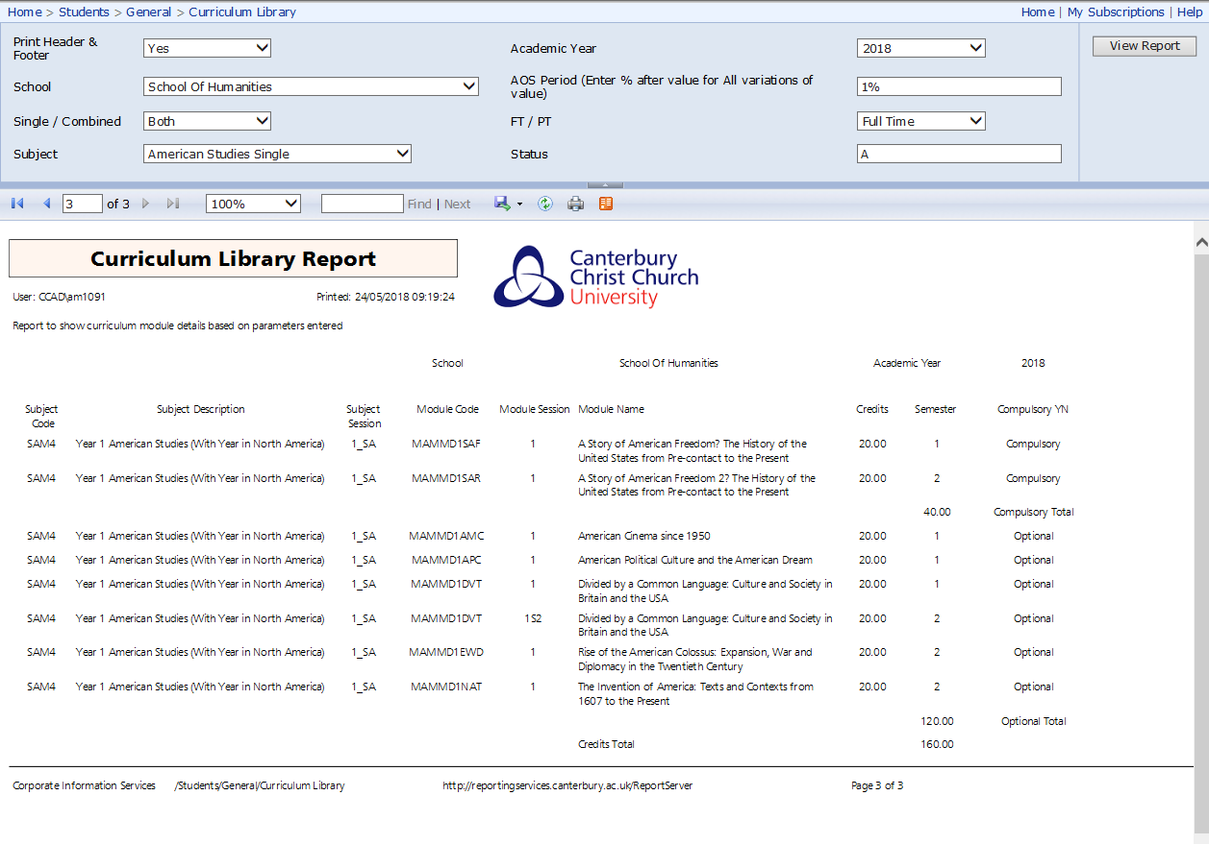



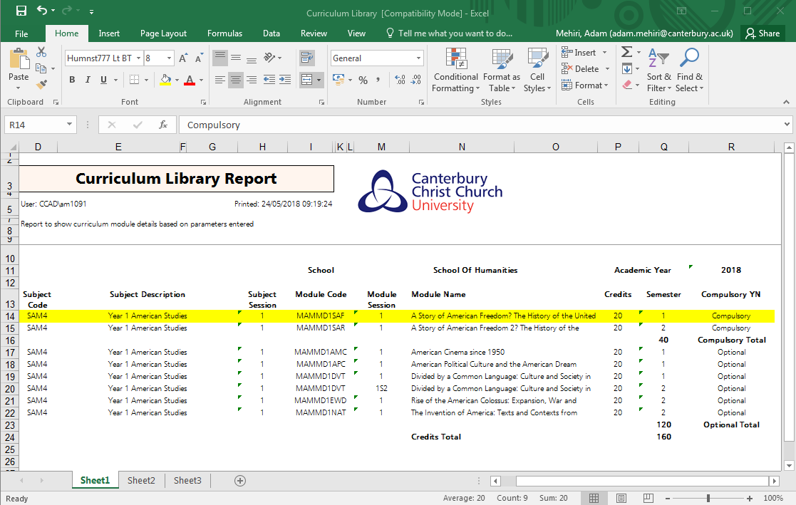

1. If you have any questions about this, please contact Data Management ([data.management@canterbury.ac.uk](mailto:data.management@canterbury.ac.uk)) to confirm which programmes would be impacted.