

**ALLIED HEALTH DEPARTMENT**

**PRACTICE LEARNING COURSE**

**Course Team:**

Fiona Fowler - Placement Lead for Speech and Language Therapy

Lindsey Keefe – Placement Lead for Occupational Therapy

**INDEX**

Page

1. Context of Practice Education 3
2. Roles and Responsibilities 4
3. Stages of Professional Development 7
4. Teaching and Learning 9
5. Supervision 13
6. Placement Models 15
7. Students with Disabilities 17
8. Appendices

**8.1** HCPC SET 5 19

**8.2** Teaching and Learning Activity 20

**8.3** Students with Disability Activity 21

**8.4** Learning Style Questionnaire 23

**8.5** Using your Learning Styles (Honey & Mumford) 29

**8.6** Using VARK Learning Style 31

**9.** References 36

**10.** Practice Learning Resources 37

|  |
| --- |
| **ACTIVITY**  In pairs identify: -   1. What’s great about having students? 2. What are you confident about? 3. What are your concerns? |

**1.CONTEXT OF PRACTICE EDUCATION**

**The Purpose of Placement**

* To allow the acquisition of professional knowledge, skills and attitudes
* To allow the theorising of practice and the practicing of theory
* To allow professional identity formation and enculturisation (process by which students are inducted and adopt their professional culture)
* Practice education is a compulsory element of a course
* Allows exposure to differing needs of various groups of individuals and the wide range of settings providing services to them
* A planned and integrated approach ensures practical experience at appropriate times to reinforce and consolidate academic aspects of the programme

**HCPC requirements for practice placements**

* Standards of Education and Training (SETs) guidance is followed by all programmes
* Informs delivery of all academic and practice placement components
* Allows eligibility to register with HCPC
* Six SETs in total with SET 5 being specifically placement related (Appendix 8.1)

**Ref: Health and Care Professions Standards for Education and Training Guidance**

**2. ROLES AND RESPONSIBILITIES**

**ACTIVITY**

* In pairs identify the potential roles of a Practice Learning Facilitator (PLF)
* List the roles below and then on the Post it note pads provided (one role per post it)

|  |
| --- |
| **NOTES** |

**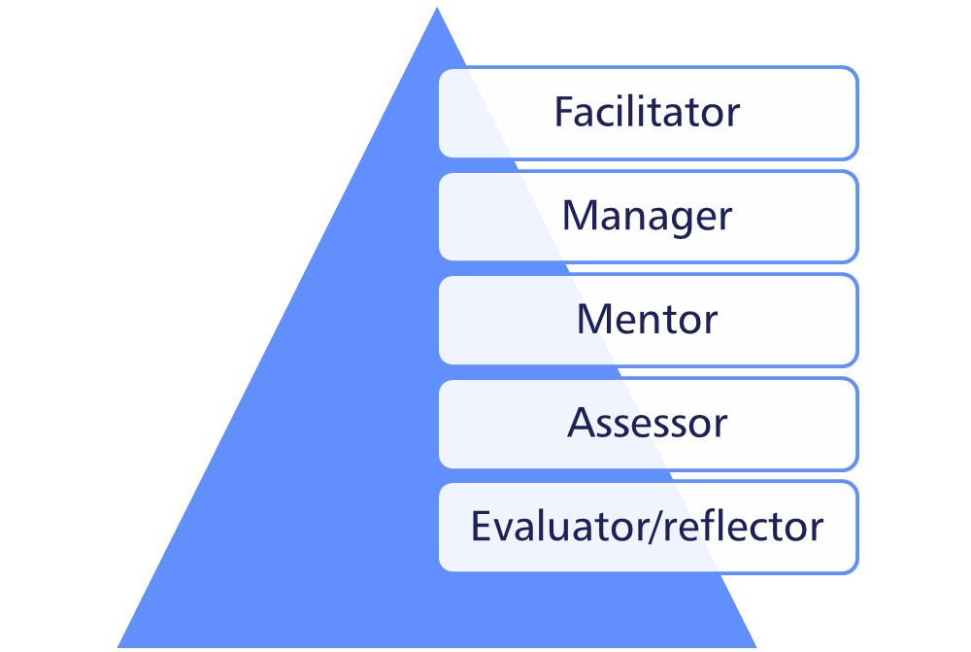**

**Facilitator**

* Partnership working with student to identify learning needs and method of learning
* Provide learning opportunities to meeting learning outcomes
* Provide supportive environment – feeling valued, sense of belonging, access to resources
* Ensure student is engaged in learning process and is able to search for their own identity

**Manager**

* Identify resources and provide pre-placement information
* Plan sessions and visits
* Advise student on expectations and practicalities
* Facilitate access to IT systems and similar
* Ensure student receives a full induction
* Manage day to day aspects and student learning
* Plan and prepare for supervision sessions
* Complete university documentation as required
* Collaborate with other professionals to optimise learning

**Mentor**

* Use knowledge and skills to influence development of student
* Provide pastoral, personal support to student
* Support student by guiding their thinking and practice

**Assessor**

* Assess the knowledge and competencies of the student against the placement learning outcomes
* Be a gatekeeper of the profession
* Interpret university outcomes into achievable practical tasks
* Gather and record evidence to support assessment outcome

**Evaluator/reflector**

* Use University and internal evaluation tools
* Feedback, discussion and supervision
* Reflective tools and reflective models
* Peer learning
* Mentorship
* Critically analyse positive and negative learning experiences
* Develop skills, knowledge and ability to facilitate learning on future placements

Polglase & Treseder (2012)

**3. STAGES OF PROFESSIONAL DEVELOPMENT**

What are the personal skills which contribute to successful learning relationships between placement educators and students?

**We will consider:**

* A sense of self
* Interpersonal communication
* Self management
* Management of others’ emotions, time and tasks.

**Do we simply become a competent placement educator?**

Unlikely! It is a process of growth and development (McAllister 1991, Edwards 1996)

We develop from NOVICE to PROFESSIONAL ARTIST!

|  |  |
| --- | --- |
| **THE NOVICE** | Strategies to Manage |
| Relatively newly qualified  ‘Persuaded’ to take a student  Didn’t feel ready but didn’t say this  Feared the student would know more than self  Dreaded being watched  Anxious about fitting everything in  Rarely reflective  BUT as a recent student possible feelings of empathy | Put on a calm front and act competently  High levels of organisation  Worked long hours  Draw on own experiences as a student  Use image of own, best PE as role, model  Begin to seek colleague support |

|  |  |
| --- | --- |
| **THE ADVANCED BEGINNER** | Strategies to Manage |
| Working for 3 years  Two students in past year  ‘Passion for learning’ and wanted to support students  Needs to be liked and responsive to students’ needs  Likes to be ‘in control’  Highly reflective | Recognise need to change own style with students particularly when they are struggling  Encourage students to place client care above their own needs  Realisation not the one responsible for a student passing or failing the placement (joint responsibility) |

**4. TEACHING AND LEARNING**

**ACTIVITY** Individual Reflection

Think of something you know you do well that you have learnt as an adult.

How did you become good at it?

What do you think supported your learning experience?

What leads to a successful learning outcome for you?

|  |
| --- |
| NOTES |

**Factors influencing learning style**

Kolb's Learning Cycle incorporating Honey and Mumford’s Learning Styles

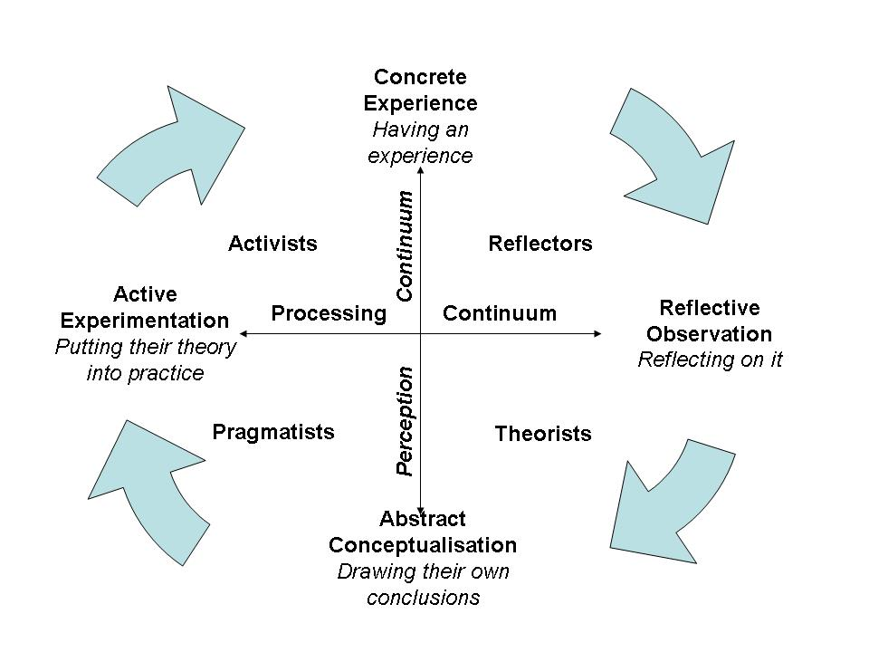

VARK Learning Preferences

Kinaesthetic Visual

MCj03550110000[1]MCBS01651_0000[1] Multi Modal

MCj03356240000[1]

Read/Write Aural



Neo-millennial Learning Style

**3 Key areas**

1. Fluency in multiple media, valuing each for the types of communication, activities, experiences, and expressions it empowers.

2. Learning based on collectively, seeking, sieving, and synthesizing experiences rather than individually locating and absorbing information from a single best source.

3. Active learning based on both real and simulated experiences that includes frequent opportunities for reflection.”  
They have fully developed sections on each of these which you are encouraged you to look at.

Dieterle, E., Dede, C., & Schrier, K. (2007)

Conscious Competence Learning Model

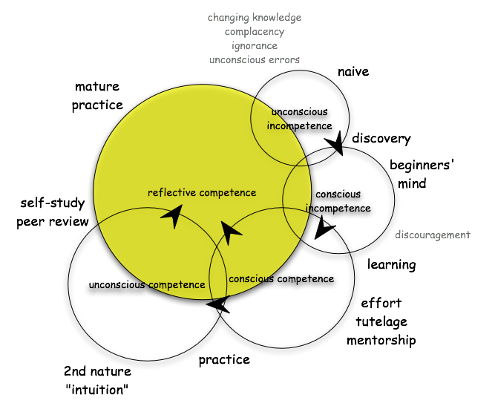

It is important to note that:

* Learning style/preference changes with tasks
* Learning style /preference varies from subject to subject
* While a student may have a preferred learning style they should also develop the others as well.

*Students taught in a manner they prefer, leads to a willingness to learn they will be better engaged, motivated and learn more effectively. Taught in a less preferred manner, provides practice and feedback in ways of thinking and solving problems which they may not initially be comfortable with but which they will have to use to be fully effective professionals.*

**5. SUPERVISION**

What is supervision?

Supervision is formally defined as a relationship between senior and junior member(s) of a profession that (a) is evaluative, (b) extends over time, (c) serves to enhance the skills of the junior person, (d) monitors the quality of the services offered by the junior person, and (e) acts as gate keeping to the profession

(Bernard & Goodyear, 1992, 2004)

**Direct Supervision:** *is provided when the Practice Educator is actually present, observing, working with and directing the student being supervised.*

**Indirect Supervision:** *is when the Practice Educator is not actually present with the student and so cannot not constantly directly observe practice*. Although not present the PE is constantly contactable by the student, and there are agreed occasions when the PE will meet with the student, and observe and assess their work.

**Formal Supervision:**

* Pre-arranged time and place (min 1 hour)
* Preparation for and agreement of an agenda
* Review of the weeks attainments in relation to learning objectives and competencies
* Identification of new learning opportunities
* Recording of significant discussion points and an agreed action plan on supervision log
* Informs formative and summative assessments

**Informal Supervision:**

* Spontaneous and immediate feedback
* Enables the student to reflect on intervention and evaluate
* Briefing and debriefing
* Developing theoretical and practical links
* Amount depends on level of training and length of time on placement
* Informs the formative assessment process

The features of effective feedback:

|  |  |
| --- | --- |
| Constructive Feedback is: | Destructive feedback is: |
| * Timely/prompt * Honest * Respectful * Unambiguous and clear * Issue specific * Supportive * Motivating/encouraging * Promotes reflection * Action and solution orientated | * Unhelpful, too generalised or vague * Accusatory * Personal   It undermines the self-esteem of the student, leaves the issue unresolved and the student unsure how to proceed. |

**ACTIVITY**  - Providing feedback

Take two sheets of paper....

* Write a “warm fuzzy” positive comment on one sheet
* Pass the sheet on to your neighbour, read the sheet you have been handed and re word clarifying the details of the achievement
* Pass the sheet on again and re word the last comment to provide clear and specific feedback
* Repeat for a “wishy washy” negative comment

Positive feedback example:

‘That was great’ – *“Warm fuzzy comment”*

‘Your communication skills are excellent *– “Clarifying achievement”*

‘I really liked the way you gave all the important information to the mother whilst reassuring her at the same time – *“Clear specific feedback”*

Constructive Criticism example:

‘Your reports are poor’ – *“Wishy washy comment”*

‘It is difficult to get a sense of what you really want to say’ – “*Vague criticism”*

‘You have all the information and if you can develop a structure to sign post the reader to the relevant information it would be helpful’ – “*Clear constructive criticism”*

Constructive Criticism Tips:

* Give criticism on performance in private
* Keep the feedback balanced
* Don’t overstate the problem by using words such as “always”, “never” or “worst”
* Pose questions that let the person do the work for you
* Stick to one subject, don’t string together criticisms at one sitting
* Don’t remind people of previous instances that were resolved.

**6. PLACEMENT MODELS**

* Apprenticeship 1:1
* Shared 1:2
* Peer 2:1
* Emerging experiences
* Buddying students
* Interdisciplinary

**What is a Peer Placement?**

Two students participating together in a placement that would traditionally be allocated to one student.

The students do NOT have to work side by side throughout the placement

**Benefits of a Peer Placement:**

* Peer placements double the capacity of placement provision.
* HEI’s are beginning to request peer placements as a standard component of a students’ practice experience.

Increasingly, health professionals are required to work as part of a team and a key mode of learning for those working in health related professions, is through peer learning

(McAllister, 1996)

**Methods of working on a peer placement:**

* One student works with a client whilst the other observes the PE.
* Both students work with a client or a group and the PE observes.
* One student works with a client or group and the other videos, for reflection and discussion between themselves and/or the PE.
* Both students visit a setting and video for the PE
* Each student sees a client and then discusses together before meeting with the PE
* One student works with a client with the PE observing whilst the other prepares/reads the client’s notes.

(Purse 2007)

**Emerging experiences**

A practice placement which occurs at a site where there is not an established therapy role. An employee at the placement setting who is not an occupational therapist or speech & language therapist who undertakes the day to day supervision of the student with but is supported by an academic from the students HEI.

**7. STUDENTS WITH DISABILITIES**

**Key Publications:**

* The Equality Act (2010)
* Special Educational Needs and Disability Act (SENDA) 2001
* Quality Assurance Agency (QAA) Code of Practice – Section 3 Students with Disabilities 1999
* A disabled persons guide to becoming a health professional (HCPC 2007)

**Definition of Disability:**

The DDA defines a disabled person as someone who has a physical or mental impairment that has a substantial and long-term adverse effect on his or her ability to carry out normal day-to-day activities.

**What is discrimination?**

Can occur in two ways:

* Treating a disabled student ‘less favourably’ for a reason relating to their disability.
* Failing to make a reasonable adjustment placing the disabled student at a disadvantage compared to their peers

**Student Responsibility**

* Disclosure
* Resources
* Review

**University Responsibility**

* Disclosure
* Advice
* Support
* Disabled students allowance

**Placement Setting Responsibility**

The DDA Part II Code of Practice (Employment and Occupation) allocates placement providers responsibilities for disabled students parallel to those for employees.

Following a student’s disclosure of their disability a range of support should be offered in the practice setting which mirrors that which they receive in the University.

**Reasonable Adjustment**

Education and training providers and other related services have a duty to make reasonable adjustments for disabled people so they are not placed at a substantial disadvantage compared to non-disabled students.

This might include adjustments to work place environment and/or the provision of support strategies.

**ACTIVITY**  Case Studies

* Using the case studies in appendix 2 identify the barriers that the student might face in practice?
* In your role as a Practice Learning Facilitator how can you assist the student to avoid or overcome these barriers?

NOTES

**8. APPENDICES**

**8.1 HCPC Standards of Education and Training (SET 5)**

5.1 Practice placements must be integral to the programme.

5.2 The number, duration and range of practice placements must be appropriate to support the delivery of the programme and the achievement of the learning outcomes.

5.3 The practice placement settings must provide a safe and supportive environment.

5.4 The education provider must maintain a thorough and effective system for approving and monitoring all placements.

5.5 The placement providers must have equality and diversity policies in relation to students, together with an indication of how these will be implemented and monitored.

5.6 There must be an adequate number of appropriately qualified and experienced staff at the practice placement setting.

5.7 Practice placement educators must have relevant knowledge, skills and experience.

5.8 Practice placement educators must undertake appropriate practice placement educator training.

5.9 Practice placement educators must be appropriately registered, unless other arrangements are agreed.

5.10 There must be regular and effective collaboration between the education provider and the practice placement provider.

5.11 Students, practice placement providers and practice placement educators must be fully prepared for placement which will include information about an understanding of:

* the learning outcomes to be achieved;
* the timings and the duration of any placement experience and associated records to be maintained;
* expectations of professional conduct
* the assessment procedures including the implications of, and any action to be taken in case of failure to progress; and
* communication and lines of responsibility

5.12 Learning, teaching and supervision must encourage safe and effective practice, independent learning and professional conduct.

5.13 A range of learning and teaching methods that respect the rights and needs of service users and colleagues must be in place throughout practice placements.

# 8.2 Learning and Teaching Activity

# Scenario

### 1)Acute Hospital Ward

Your student is a strong reflector and has identified themselves as an aural learner. This is apparent in MDT environments where your student is quiet and listens but contributes very little. Informally, they communicate well with other team members. However they are required to engage and actively participate in formal communication tasks and their learning style appears to be impacting on their performance in these tasks.

### 2) Clients Home.

Your student is eager and keen to learn and has identified their strengths are as a kinaesthetic learner and they are more of activist in style. You have talked through an assessment tool and the student appears to have understood what is required of them. However, it becomes apparent during the session that the student is struggling to complete the assessment.

### 3) Outpatients Department

Your student has identified their learning style as a theorist and their learning preference is read/write. They have read the key literature required for this stage of training but has expressed feeling that they have a lack of sufficient background knowledge. They have requested further reading and are anxious about engaging with patients.

### 4) Day Services

Your student’s preference is as a pragmatist and visual learner. They have shown good presentation skills during a staff training session, engages well with clients, staff and carers and gathered the information regarding service users. However, they struggle to document information in the required written format for the setting.

**Consider:-**

**What would you do as the educator?**

**What would you encourage the student to do?**

**What would you do to adjust the learning environment?**

**8.3 Students with Disabilities Activity**

**Student Case Study 1**

Max, is a student with mental health difficulties. He experiences generalised anxiety disorder and has experienced periods of depression in the past. His life experiences influenced his decision to study. He would like to help others with the knowledge he has gained from his experiences. He feels apprehensive and anxious when encountering new people and entering new situations. On the eve of a placement commencing he describes being unable to sleep, and therefore on first day he feels tired and this impacts on his ability concentrate and take on board new information. The feelings of anxiety are also raised when he is being assessed. He finds receiving critical feedback stressful and has experienced a panic attack following an assessed intervention session.

**How accessible is your placement setting for Max**

What adjustments do you need to make in order for Max to have equal access to your placement learning opportunities?

**Student Case Study 2**

Jo is dyslexic, she has her own computer and uses computer software packages that help her to ‘read’ and ‘prepare’ written material. She uses mind mapping strategies to capture and organise her thoughts. She requires additional time to read through and digest new information. University accommodations have been extended loan periods for library books and additional 15 minutes per hour examination time. Jo appreciates receiving identify key texts on reading lists prior to placement so she can adequately prepare. She finds handouts using Arial size 12 font on green paper aid her reading speed. She also values access to source material in alternative media (tapes, videos, CD -ROMs) to support her comprehension of the subject of study.

**How accessible is your placement setting for Jo**

What adjustments do you need to make in order for Jo to have equal access to your placement learning opportunities?

**Student Case Study 3**

Cathy is a student with hearing loss. She has found that coming to university, from a school where there were smaller numbers of students and more access to teachers, has been intimidating. At university she has found group work difficult, as she often finds it difficult to know who is speaking, and to follow what other students are saying. She has found that not all the teaching rooms are equipped with a hearing loop system. Without this system in place, she has considerable difficulties hearing and has to rely on lip-reading. She has encountered difficulties with people who turn away when speaking making it impossible for her to lip-read. She also finds it difficult to write and follow a lecture at the same time; this has been overcome in the classroom with the assistance of a scribe to take notes.

**How accessible is your placement setting for Cathy**

What adjustments do you need to make in order for Cathy to have equal access to your placement learning opportunities?

**Student Case Study 4**

Jane experiences tenosynovitis after an upper limb injury of her dominant limb. Since her injury her handwriting is has deteriorated and when inflamed she can hardly read her own handwriting. If Jane writes for any amount of time the joints are painful. The pain can only be eased by initially applying a cold pack and then rested for hours or days depending on its severity. She also needs to pace her computer use limiting periods of searching/typing etc.  Jane uses a Dictaphone to record lectures, after the lecture she then makes her own notes. She can take a 30 rest break per hour examination time. In addition to writing and typing tasks she needs to pace repetitive upper limb tasks such as operating and fitting equipment to ensure adequate rest.

**How accessible is your placement setting for Jane**

What adjustments do you need to make in order for Jane to have equal access to your placement learning opportunities?

**8.4 LEARNING STYLES QUESTIONNAIRE** Revised 1986

This questionnaire is designed to find out your preferred learning style(s). Over the years you have probably developed learning ‘habits’ that help you benefit more from some experiences than from others. Since you are probably unaware of this, this questionnaire will help you pinpoint your learning preferences so that you are in a better position to select learning experiences that suit your style.

There is no time limit to this questionnaire. It will probably take you 10-15 minutes. The accuracy of the results depends on how honest you can be. There are no right or wrong answers. If you agree more than you disagree with a statement put a tick by it (✓). If you disagree more than you agree put a cross by it (x). Be sure to mark each item with either a tick or cross.

🞎 1. I have strong beliefs about what is right and wrong, good and bad.

🞎 2. I often act without considering the possible consequences.

🞎 3. I tend to solve problems using a step-by-step approach.

🞎 4. I believe that formal procedures and policies restrict people.

🞎 5. I have a reputation for saying what I think, simply and directly.

🞎 6. I often find that actions based on feelings are as sound as those based on careful thought and analysis.

🞎 7. I like the sort of work where I have time for thorough preparation and implementation.

🞎 8. I regularly question people about their basic assumptions.

🞎 9. What matters most is whether something works in practice.

🞎 10. I actively seek out new experiences.

🞎 11. When I hear about a new idea or approach I immediately start working out how to apply it in practice.

🞎 12. I am keen on self discipline such as watching my diet, taking regular exercise, sticking to a fixed routine, etc.

🞎 13. I take pride in doing a thorough job.

🞎 14. I get on best with logical, analytical people and less well with spontaneous, ‘irrational’ people.

🞎 15. I take care over the interpretation of data available to me and avoid jumping to conclusions.

🞎 16. I like to reach a decision carefully after weighing up many alternatives.

🞎 17. I’m attracted more to novel, unusual ideas than to practical ones.

🞎 18. I don’t like disorganised things and prefer to fit things into a coherent pattern.

🞎 19. I accept and stick laid down procedures and policies so long as I regard them as an efficient way of getting the job done.

🞎 20. I like to relate my actions to a general principle.

🞎 21. In discussions I like to get straight to the point.

🞎 22. I tend to have distant, rather formal relationships with people at work.

🞎 23. I thrive on the challenge of tackling something new and different.

🞎 24. I enjoy fun-loving, spontaneous people.

🞎 25. I pay meticulous attention to detail before coming to a conclusion.

🞎 26. I find it difficult to produce ideas on impulse.

🞎 27. I believe in coming to the point immediately.

🞎 28. I am careful not to jump to conclusions too quickly.

🞎 29. I prefer to have as many sources of information as possible – the more data to think over the better.

🞎 30. Flippant people who don’t take things seriously enough usually irritate me.

🞎 31. I listen to other people’s points of view before putting my own forward.

🞎 32. I tend to be open about how I’m feeling.

🞎 33. In discussions I enjoy watching the manoeuvrings of the other participants.

🞎 34. I prefer to respond to events on a spontaneous, flexible basis rather than plan things out in advance.

🞎 35. I tend to be attracted to techniques such as network analysis, flow charts, branching programmes, contingency planning, etc.

🞎 36. It worries me if I have to rush out a piece of work to meet a tight deadline.

🞎 37. I tend to judge people’s ideas on their practical merits.

🞎 38. Quiet, thoughtful people tend to make me feel uneasy.

🞎 39. I often get irritated by people who want to rush things.

🞎 40. It is more important to enjoy the present moment than to think about the past or future.

🞎 41. I think that decisions based on a thorough analysis of all the information are sounder than those based on intuition.

🞎 42. I tend to be a perfectionist.

🞎 43. In discussions I usually produce lots of spontaneous ideas.

🞎 44. In meetings I put forward practical, realistic ideas.

🞎 45. More often than not, rules are there to be broken.

🞎 46. I prefer to stand back from a situation and consider all the perspectives.

🞎 47. I can often see inconsistencies and weaknesses in other people’s arguments.

🞎 48. On balance I talk more than I listen.

🞎 49. I can often see better, more practical ways to get things done.

🞎 50. I think written reports should be short and to the point.

🞎 51. I believe that rational, logical thinking should win the day.

🞎 52. I tend to discuss specific things with people rather than engaging in social discussion.

🞎 53. I like people who approach things realistically rather than theoretically.

🞎 54. In discussions I get impatient with irrelevancies and digressions.

🞎 55. If I have a report to write I tend to produce lots of drafts before settling on the final version.

🞎 56. I am keen to try things out to see if they work in practice.

🞎 57. I am keen to reach answers via a logical approach.

🞎 58. I enjoy being the one that talks a lot.

🞎 59. In discussions I often find I am the realist, keeping people to the point and avoiding wild speculations.

🞎 60. I like to ponder many alternatives before making up my mind.

🞎 61. In discussions with people I often find I am the most dispassionate and objective.

🞎 62. In discussions I’m more likely to adopt a ‘low profile’ than to take the lead and do most of the talking.

🞎 63. I like to be able to relate current actions to a longer term bigger picture.

🞎 64. When things go wrong I am happy to shrug it off and ‘put it down to experience’.

🞎 65. I tend to reject wild, spontaneous ideas as being impractical.

🞎 66. It’s best to think carefully before taking action.

🞎 67. On balance I do the listening rather than the talking.

🞎 68. I tend to be tough on people who find it difficult to adopt a logical approach.

🞎 69. Most times I believe the end justifies the means.

🞎 70. I don’t mind hurting people’s feelings so long as the job gets done.

🞎 71. I find the formality of having specific objectives and plans stifling.

🞎 72. I’m usually one of the people who puts life into a party.

🞎 73. I do whatever is expedient to get the job done.

🞎 74. I quickly get bored with methodical, detailed work.

🞎 75. I am keen on exploring the basic assumptions, principles and theories underpinning things and events.

🞎 76. I’m always interested to find out what people think.

🞎 77. I like meetings to be run on methodical lines, sticking to laid down agenda, etc.

🞎 78. I steer clear of subjective or ambiguous topics.

🞎 79. I enjoy the drama and excitement of a crisis situation.

🞎 80. People often find me insensitive to their feelings.

**LEARNING STYLES QUESTIONNAIRE – SCORING**

You score one point for each item you ticked (✓). There are no points for items you crossed (x). Simply indicate on the lists below which items were ticked.

2 7 1 5

4 13 3 9

6 15 8 11

10 16 12 19

17 25 14 21

23 28 18 27

24 29 20 35

32 31 22 37

34 33 26 44

38 36 30 49

40 39 42 50

43 41 47 53

45 46 51 54

48 52 57 56

58 55 61 59

64 60 63 65

71 62 68 69

72 66 75 70

74 67 77 73

79 76 78 80

\_\_\_\_\_\_\_\_\_\_\_\_\_\_\_ \_\_\_\_\_\_\_\_\_\_\_\_\_\_\_ \_\_\_\_\_\_\_\_\_\_\_\_\_\_\_\_ \_\_\_\_\_\_\_\_\_\_\_\_\_\_\_

Totals

\_\_\_\_\_\_\_\_\_\_\_\_\_\_\_ \_\_\_\_\_\_\_\_\_\_\_\_\_\_\_ \_\_\_\_\_\_\_\_\_\_\_\_\_\_\_\_ \_\_\_\_\_\_\_\_\_\_\_\_\_\_\_

Activist Reflector Theorist Pragmatist

Ring your scores on this chart and join up.

|  |  |  |  |  |
| --- | --- | --- | --- | --- |
| Activist | Reflector | Theorist | Pragmatist |  |
| 20  19  18  17  16  15  14  13 | 20  19  18 | 20  19  18  17  16 | 20  19  18  17 | Very strong preference |
| 12  11 | 17  16  15 | 15  14 | 16  15 | Strong preference |
| 10  9  8  7 | 14  13  12 | 13  12  11 | 14  13  12 | Moderate preference |
| 6  5  4 | 11  10  9 | 10  9  8 | 11  10  9 | Low preference |
| 3  2  1  0 | 8  7  6  5  4  3  2  1  0 | 7  6  5  4  3  2  1  0 | 8  7  6  5  4  3  2  1  0 | Very low preference |

**8.5 USING YOUR LEARNING STYLES (Honey & Mumford)**

**Key questions for Activists**

Shall I learn something new, i.e. that I didn’t know/couldn’t do before?

Will there be a wide variety of different activities? (I don’t want to sit and listen for more than an hour at a stretch!)

Will it be OK to have a go/let my hair down/make mistakes/have fun?

Shall I encounter some tough problems and challenges?

Will there be other like-minded people to mix with?

**Key questions for Reflectors**

Shall I be given adequate time to consider, assimilate and prepare?

Will there be opportunities/facilities to assemble relevant information?

Will there be opportunities to listen to other people’s point of view - preferably a wide cross section of people with a variety of views?

Will I be under pressure to slap-dash or to extemporize?

**Key questions for Theorists**

Will there be lots of opportunities to question?

Do the objectives and programme of events indicate a clear structure and purpose?

Shall I encounter complex ideas and concepts that are likely to stretch me?

Are the approaches to be used and concepts to be explored ‘respectable’ i.e. sound and valid?

Shall I be with people of similar calibre to myself?

**Key questions for Pragmatists**

Will there be ample opportunities to practise and experiment?

Will there be lots of practical tips and techniques?

Shall we be addressing **real** problems and will it result in action plans to tackle some of **my** current problems?

Shall we be exposed to experts who know how to/can do it themselves?

Honey P and Mumford A (1986). Using Your Learning Styles. Maidenhead, Pritique

**Activists -** Activists involve themselves fully and without bias in new experiences. They enjoy the here and now and are happy to be dominated by immediate experiences. They are open-minded, not sceptical, and this tends to make them enthusiastic about anything new. Their philosophy is: ‘I’ll try anything once’. They tend to act first and consider the consequences afterwards. Their days are filled with activity. They tackle problems by brainstorming. As soon as the excitement from one activity has died down they are busy looking for the next. They tend to thrive on the challenge of new experiences but are bored with implementation and longer term consolidation. They are gregarious people constantly involving themselves with others but, in doing so, they seek to centre all activities around themselves.

**Reflectors -** Reflectors like to stand back to ponder experiences and observe them from many different perspectives. They collect data, both first hand and from others, and prefer to think about it thoroughly before coming to any conclusion. The thorough collection and analysis of data about experiences and events is what counts so they tend to postpone reaching definitive conclusions for as long as possible. Their philosophy is to be cautious. They are thoughtful people who like to consider all possible angles and implications before making a move. They prefer to take a back seat in meetings and discussions. They enjoy observing other people in action. They listen to others and get the drift of the discussion before making their own points. They tend to adopt a low profile and have a slightly distant, tolerant, unruffled air about them. When they act it is part of a wide picture which includes the past as well as the present and others’ observations as well as their own.

**Theorists -** Theorists adapt and integrate observations into complex but logically sound theories. They think problems through in a vertical, step-by-step logical way. They assimilate disparate facts into coherent theories. They tend to be perfectionists who won’t rest easy until things are tidy and fit into a rational scheme. They like to analyse and synthesize. They are keen on basic assumptions, principles, theories, models and systems thinking. Their philosophy prizes rationality and logic. ‘If it’s logical it’s good’. Questions they frequently ask are: ‘Does it make sense?’ ‘How does this fit with that?’ ‘What are the basic assumptions?’ They tend to be detached, analytical and dedicated to rational objectivity rather than anything subjective or ambiguous. Their approach to problems is consistently logical. This is their ‘mental set’ and they rigidly reject anything that doesn’t fit with it. They prefer to maximise certainty and feel uncomfortable with subjective judgements, lateral thinking and anything flippant.

**Pragmatists -** Pragmatists are keen on trying out ideas, theories and techniques to see if they work in practice. They positively search out new ideas and take the first opportunity to experiment with applications. They are the sort of people who return from management courses brimming with new ideas that they want to try out in practice. They like to get on with things and act quickly and confidently on ideas that attract them. They tend to be impatient with ruminating and open-ended discussions. They are essentially practical, down to earth people who like making practical decisions and solving problems. They always respond to problems and opportunities ‘as a challenge’. Their philosophy is: ‘There is always a better way’ and ‘if it *works* its good’.

© Honey and Mumford 1986

**8.6 Using VARK Learning Style**

|  |
| --- |
| **Auditory/Aural learners** |

The aural learner in developing their knowledge of a subject will:

* Attend in-services.
* Arrange for specific tutorials on a subject.
* Want to discuss their understandings with the fieldwork educator, with other students and with other staff.
* Will want to talk with clients to gain an understanding of their ‘illness experience’.
* Will find it easier to remember information if told a story about it.
* Will want to interview members of the team and ask about roles etc. to understand how the service is structured.
* Will ask others to ‘hear’ their understandings of topics.

To develop skills they will:

* Ask the fieldwork educator to explain how they carry out a particular technique.
* Will talk their way through a particular task.
* May have very good recall of what clients have said to them.

To reflect

* Will want to talk with the supervisor about their observations and understandings. May find journaling difficult, therefore better to tape their thoughts and then listen through again. Will benefit from time to listen to their ‘inner voice’ and to take note of what is being said!

To manage learning contracts on placement:

* Will probably prefer to make a verbal agreement, than to have it all written down in specific objectives, learning resources and outcomes.
* May prefer to talk through with you first about what they would like to include in the contract.

To demonstrate learning

* Will prefer to tell you what they have done or achieved.
* Probably will feel more comfortable with case study presentations to the team.

To receive feedback

* Of all learning styles, this learner will retain the majority of feedback that you give in a verbal situation. Will want to receive verbal feedback over written, and will want to discuss the feedback to truly understand what is required.

|  |
| --- |
| From the website at [www.vark-learn.com](http://www.vark-learn.com):  If you are an aural learner you will prefer to have this entire page explained to you. The written words are not as valuable as those you hear. You will probably go and tell somebody about this. |

|  |
| --- |
| **Visual learners** |

The visual learner in developing their knowledge of a subject will:

* Attend in-services where diagrammatic material is used to illustrate points.
* Use visual means to highlight important information.
* Ask for flow charts to understand relationships/structures of the service.
* Utilise visual resources in the department, particularly those that are more diagrammatic in nature.
* Respond well to people who can illustrate principles in a diagrammatic way.
* This student will want to observe the other team members working with the client, rather than hear a description.

To develop skills will:

* Will want to observe, observe, observe before doing.
* Will be able to visualise the layout of a clients home without difficulty and will make observations of the client’s performance (once they understand the bigger picture).

To reflect

* Will visualise particular situations. May use diagrams, flow charts and mindmaps instead of a written journal.

To manage learning contracts on placement:

* Will need an overview of the whole placement. Once this is clear, will probably be able to construct reasonably good learning contracts.

To demonstrate learning

* Will prefer to have you see what it is they are doing, but may also provide you information in poster format etc. Will make good use of visual material to demonstrate understandings (e.g. design of brochures).

To receive feedback

* This student will find that they capture more of the feedback you give, it if is given using diagrams and charts and other illustrations.

|  |
| --- |
| From the website at [www.vark-learn.com](http://www.vark-learn.com):  You are holistic rather than reductionist in your approach. You want the whole picture. Visual learners do not like handouts, words or textbooks, which are very text based. You prefer to watch videos of scenarios than to read about them |

|  |
| --- |
| **Kinaesthetic learners** |

The kinaesthetic learner in developing their knowledge of a subject will:

* Draw on information from all senses sight, touch, hearing, smell etc.
* Prefers inservices where real examples are given.
* Learns best through examples and trial and error.
* Want to make any theoretical learning real to them – use of role plays can be really useful for example, but any tasks that assists them to gain knowledge through doing will be beneficial.
* Draw on previous experiences, will go back to resources collected before that may be relevant (especially if they have made them).
* Use video resources of real situations.

To develop skills will:

* Want to be involved in everything that you do from the beginning, and be able to take part in all aspects of your role
* Benefit from role plays, simulation and practice

To reflect will:

* Probably reflect by ‘walking’ through their experiences in their minds. Journaling would be a challenging task for this type of learner. They would prefer to do, then to act out what has happened in order to make sense of the experience.

To manage learning contracts on placement:

* Would appreciate seeing examples of other learning contracts before making a decision.
* The contract would focus on what has to be done (input and tasks) rather than outcomes.

To demonstrate learning

* Will prefer to show you what they have done, and where possible have you involved in the experience as well.

To receive feedback

* The person with this type of learning style would probably wish to reflect on the experience first, by ‘walking’ through in their mind what they have done. They would probably benefit from very descriptive feedback, where the supervisor describes exactly what did or didn’t happen. They may find it easier if you show (demonstrate) rather than tell them!

|  |
| --- |
| From the website at [www.vark-learn.com](http://www.vark-learn.com):  These students want to have the experience in order to understand. Fieldwork is the ideal place for the student to integrate theory to practice. Ideas on this page are only valuable if they sound practical, real and relevant. They need to do in order to understand. |

|  |
| --- |
| **Reader/writer learners** |

The learner who finds they learn most from reading/writing in developing knowledge of a subject will:

* Find written textual based information the easiest and quickest to process
* Want to read through your department and hospital library
* Use dictionaries/glossaries as resources
* Read clinical notes, reviews of services etc
* Make prolific notes at in-services/team meetings etc
* draw heavily on manuals and clinical guidelines
* Use any written resources available

To develop skills will:

* Want to read about the skills first
* Work well with a supervisor who is articulate in their thinking

To reflect will

* Be prolific journal writers, and find journaling a very useful process to develop their understanding

To manage learning contracts on placement:

* Learning contracts will be very specific, but may revolve more around reading/writing than students with other learning styles

To demonstrate learning

* Will prefer to have the supervisor read something that they have written.
* May produce journal as evidence that objective(s) have been achieved.

To receive feedback

* May write down the feedback as they ‘hear it’. Will find it hard to process feedback if this is only provided aurally. Benefit from written summaries of their progress to reflect on.

|  |
| --- |
| From the website at [www.vark-learn.com](http://www.vark-learn.com):  You like this page because the emphasis is on words and lists. You believe the meanings are within the words, so the talk is OK, but the handout is better. You are heading home to read it again! |

Prepared by: with input from:

Merrolee Penman, NZROT, MA (Educ) Neil D. Fleming

Senior Lecturer Teacher/Consultant

Otago Polytechnic. Christchurch, NZ

200

**9 REFERENCES:**

Alsop A & Ryan S (1996): *Making the Most of Fieldwork Education: A Practical approach* London: Chapman & Hall

Baird. D, Learning Styles 2.0: Digital, Social, and Always On, 02 April 2006. Retrieved on Oct 4, 2007, from <http://www.debaird.net/blendededunet/2006/04/learning_styles.html>

Dede, C. (2005). Planning for Neomillennial Learning Styles: Implications for Investments in Technology and Faculty. In D. G. Oblinger & J. L. Oblinger (Eds.), Educating the net generation. Retrieved November 20, 2006, from: <http://www.educause.edu/content.asp?page_id=6069&bhcp=1>

Dede, C. (2005). Planning for Neomillennial learning styles: Shifts in students’ learning style will prompt a shift to active construction of knowledge through mediated immersion. Retrieved on Oct 4, 2007, from <http://connect.educause.edu/library/abstract/PlanningforNeomillen/39899>

Department of Health (2003): *The Chief Health professions Officers ten Key Roles for Allied Health Professional* Department of Health Publications, London

Dieterle, E., Dede, C., & Schrier, K. (2007). “Neomillennial” learning styles propagated

by wireless handheld devices. In M. Lytras & A. Naeve (Eds.), *Ubiquitous and pervasive knowledge and learning management: Semantics, social networking and new media to*

*their full potential*. Hershey, PA: Idea Group, Inc.

Downes, S, National Research Council of Canada, E-learning 2.0. Retrieved on Oct 10, 2007,from <http://www.elearnmag.org/subpage.cfm?section=articles&article=29-1>

Polgase T, Treseder R (2012) The Occupational Therapy handbook:Practice Education. Keswick :Ferguson Print

Waters B (2001): *Radical Action for Radical Plans.* The British Journal of Occupational Therapy (64(ii)577 -578)

Will Taylor, Chair, Department of Homeopathic Medicine, National College of Natural Medicine, Portland, Oregon, USA, March 2007 acquired from <http://www.businessballs.com/consciouscompetencelearningmodel.htm>

**Canterbury Christ Church University Practice Learning Unit:**

http://www.canterbury.ac.uk/health-and-wellbeing/practice-learning-unit/practice-learning-unit.aspx

**10.PRACTICE LEARNING RESOURCES**

**Interprofessional learning/Context of Education**

<http://www.caipe.org.uk/>

<http://www.qaa.ac.uk/>

<http://www.heacademy.ac.uk/>

**Practice Based Learning**

<http://www.faculty.londondeanery.ac.uk//e-learning>

<http://www.naep-uk.org/>

**Teaching and Learning**

<http://vark-learn.com/strategies/>.

<http://businessballs.com/kolblearningstyles.htm>

<http://www.debaird.net/blendededunet/2006/04/learning_styles.html>

<http://connect.educause.edu/library/abstract/PlanningforNeomillen/39899>

<http://edorigami.wikispaces.com/NeoMillennial+Learning+styles>

<http://www.businessballs.com/consciouscompetencelearningmodel.htm>

**Students requiring learning support**

<http://www.southampton.ac.uk/edusupport/ldc/> (supporting Dyslexic students on practice placements)

**Professional Bodies**

<http://www.rcslt.org> Royal College of Speech and Language Therapists

https://www.rcot.co.uk/ (Available to COT members only)

<http://www.hpc-uk.org/> (Includes Standards of Education and Training)

<http://www.hpc-uk.org/publications/research/index.asp?id=511> (Professionalism in Healthcare Professions)

**Texts**

Bray, Ross & Todd (2006) *Speech and Language: Clinical Process and Practice*. 2nd ed. London: Wiley

Brockbank, A., McGill I. & Beech N. (2002) *Reflective learning in Practice.* Aldershot: Gower Press

Brumfitt, S. (2004) Innovations in Professional Education for Speech and Language Therapy. Whurr Publishers Ltd

Eraut, M. (1994) *Developing Professional Knowledge and Competence* London: The Falmer Press.

Goppee, N. (2011) Mentoring and supervision in healthcare London:Sage

Goppee, N. (2011) Practice teaching in healthcare London:Sage

Healey J. & Spencer, M. (2008) Surviving your Placement in Health and Social Care. A Student Handbook. Open University:Maidenhead

Heron, J. (1999) The complete facilitators handbook Kogan Page

Johns, C (2004) *Becoming a Reflective Practitioner.* Oxford: Blackwell Publishing, 2nd edition

Kinnell, P. Hughes, P. (2010) Mentoring nursing and healthcare students London:Sage

Kolb, D. (1984) *Experiential Learning,* Englewood Cliffs: Prentice Hall

McAllister, L. & Lincoln, M. (2004) Clinical Education in Speech and Language Pathology Whurr Publishers Ltd. 2004

Moore, A. Hilton R. Morris, J. Caladine. L Bristow H (1997) The Clinical Educator – Role Development. A Self Directed Learning Text. Churchill Livingstone

Mulholland, J. Turnock, C. (2013) Learning in the Workplace 2nd Edition Routledge:Abingdon

Polgase, T. Treseder, R. (2012) The Occupational Therapy Handbook: Practice Education M&K Publishing

Schon, D.A. (1987) Educating the Reflective Practitioner. Josey-Bass, New York

Stuart, C.C. (2003) Assessment, Supervision and Support in Clinical Practice. Churchill Livingstone, Edinburgh