Cathy Bernal

An Evaluation of “LOUD”

TAble of
Contents
background 1
Approach 3
Analysis 4
Theme 1: unease 5
Theme 2: Learning and Developing 6
Theme 3: Becoming Autonomous 8
Theme 4: Organisation Aspects 9
Discussion 10
conclusion and next steps 11
Appendix 1: Simulated hospital admissions 13
appendix 2: questionnaire 15

background
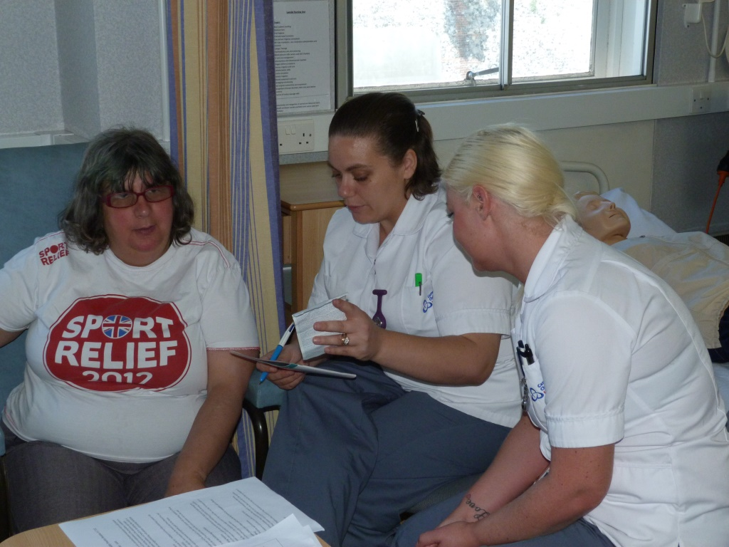
The acronym LOUD stands for “Learning; Observing; Understanding; Disability”, and is the name chosen by its members for our university’s consultant group of co-teachers with learning disabilities. LOUD has been in existence since April 2015, and is tasked with monitoring and developing the quality of learning disability education within the Faculty of Health and Wellbeing. Its members are people with learning disabilities [PLD] who regularly teach on the faculty’s programmes, and it meets in alternate months throughout the academic year.
LOUD was founded in response to a growing realisation in UK healthcare that service user involvement in healthcare education is a necessary prerequisite of prospective practitioners’ ability to deliver person-centred care. There is a considerable amount of evidence demonstrating the impact that such teaching can have on student outcomes, but opportunities for groups of people with learning disabilities to influence the content and direction of this teaching in this country appear to have been few. In addition, there is correspondingly very little evidence of the value of involving PLD in decision-making in relation to such education.
Hence funding was secured from Health Education Kent, Surrey and Sussex to help establish and evaluate LOUD, and in the three years since its inception, members have reviewed the teaching they have delivered, commented on potential teaching opportunities, and discussed ongoing matters such as payment for their time. A frequent topic of discussion in meetings has been the “Simulated Hospital Admissions” that the majority of LOUD members deliver (with the help of a lecturer) to Adult Nursing students.
The detailed structure of a Simulated Hospital Admission [SHA] is given in Appendix 1; suffice to state here that the day – which takes place in the university’s simulation suite, or mock ward - is designed to help Adult Nursing students to understand the health inequalities that PLD typically face, and to enable the students to make reasonable adjustments to their care in future.
Although the fundamental structure of the SHAs has not changed, discussions at LOUD have influenced the ways in which they are presented. For example, volunteers are never referred to as “service users” (a term of abhorrence to the group), but as “co-teachers”, a term that the members felt would afford them greater respect. Following student feedback, a decision was also made by another meeting to swap students in the course of the SHA when time permitted, thus giving both co-teacher and student a broader range of experience. At the same meeting, members agreed to use an easy-read and short questionnaire as an alternative to the customary healthcare passport if the latter was proving too onerous for the co-teacher. On another occasion, the possibility of conducting the SHAs in a classroom (due to pressure on the simulation suite) was discussed, and rejected by the members. All these decisions have been put into practice by the lecturers facilitating the SHAs.
Hence, since LOUD members have had a significant influence on the recent delivery of the SHAs, it seemed logical to evaluate the impact of the group through an assessment of the impact of the simulations upon student learning.

Approach
The prospective research was submitted for approval to the Faculty of Health and Wellbeing ethics committee, and authorisation to proceed was gained.
The researchers (the author and research assistant Victoria Stirrup) opted to design and deploy an online questionnaire that students who had participated in the SHA would be invited to complete. The aim was to evaluate the nature and extent of their learning as the result of an experience in the design of which LOUD members had played a significant part.
As the researchers wished to involve the members of LOUD as far as possible in this project, the latter were consulted in a routine meeting about the content of the questionnaire. They were invited to respond to three questions:
• What do we do well?
• How do we do it?
• How could we do it better?
Their feedback resulted, with contributions from the researchers, in the content of the questionnaire that was used (see appendix 2). All currently registered Adult Nursing students that had taken part in an SHA were then invited to complete the questionnaire.
Unfortunately, only a very small number of responses were received, and this is possibly the consequence of the stipulation from the ethics committee that interested students would need to apply for a consent form and further information about the project from the research assistant, before printing, scanning and returning the former in a process that may have deterred some prospective participants. Out of a potential 621 responses, only 6 were received; fortunately, the researchers noted that these 6 contained quite extensive material, providing a rich source of information.

Analysis
The students’ responses were subject to thematic analysis. This involved the researchers immersing themselves in the information submitted in order to identify significant commonalities, and grouping them into themes. The themes identified are illustrated in Fig 1.

Theme 1: unease
Theme 2: learning and developing
2.1: learning journey
2.2: developing a competency
Theme 3: becoming autonomous
Theme 4: organizational aspects
Fig 1: themes identified in the questionnaire responses

Theme 1: unease
This finding was a surprise to the researchers. One of the students commented that their experience had been “awkward”, due to the seeming reluctance of the co-teachers to participate on the day in question. This was at odds with CB’s personal experience of the manifest enjoyment of the co-teachers during the simulations she has conducted, and those reported to her by facilitating colleagues, and so has generated some concern. There were also more subtle expressions of alienation from the students, including frequent reference by some to the co-teachers using third person plural pronouns (i.e. “they” and “them”), for example:
“we were able to take a blood pressure from them and they were ok about it”; and
“even simple words can confuse them so keep sentences short”.
This seemed to indicate a distancing from the co-teachers and a tendency to regard them as a class of people, rather than as a collection of distinct individuals.

Theme 2: Learning and Developing
This theme was subdivided by the researchers into two subsidiary themes; the learning journey, and developing a competency. Both were characterised by the generation of insight and skill, and the awareness of students that they were on a trajectory of professional development.

2.1: The Learning Journey
Whilst one respondent acknowledged the usefulness of having had prior experience with PLD, they also stated that the SHA had offered them the opportunity to develop “greater insight” into the potential anxieties for an individual with learning disabilities being admitted to hospital. The development of insight was also mentioned by others, one stating that the day emphasised “how vulnerable they really are”, and another that they had learned how “to value people from a socially marginalised group”. Some participants seemed to have had their expectations of the day exceeded, and this was linked to expressions of appreciation. One student also referred to the gratitude they had expressed to the co-teachers for “what a good they done in helping me to learn a new skill”, and another commented that, “some people were withdrawn from playing ice breaker games but when we were to ask consent to take a blood pressure one surprised and came around by participating”.
Responses from all but one participant indicated a positive experience of learning; in answer to the invitation to describe the day, different students used such words as “fantastic”, “positive” and “amazing”. Some commented on what they perceived as an element of mutuality, with one stating that a helpful factor was “the games we played” (note the use of the first person), and another that “finding common ground between us” assisted them to establish rapport with a co-teacher who had initially been reluctant. This mutuality sometimes manifested itself in skills sharing, with one respondent stating that “explaining how to use things in the skills lab” in a way that was “basic” facilitated the development of adaptive communication skills. Mutual benefit was also commented upon, with one contributor reflecting that, “I got to learn or practise my skills and they got the chance to benefit what it might be like if they actually had to go into hospital.”
Comments were also made about the potential and limits of simulation. Whilst one student acknowledged that “there were a variety of individuals who attended”, another deemed that the session in which they had participated featured only co-teachers who were “relatively independent”. However, several people felt that participation in the day had facilitated the recognition of individuality and the ability to personalise assessment and care; one respondent indicated that the simulation had offered that “no two people are the same”, and another said that it would have been helpful to have been able to talk to a carer prior to the simulation about the co-teacher’s particular needs. There appeared to be learning that would result in a more flexible approach in practice from the participants, with one stating that they were prompted to “think about different areas and things that you haven't seen on placement yet but may see”.

2.2: Developing a Competency
Several students mentioned the acquisition of particular skills. Sometimes this was related to gaining knowledge of the tools used, such as the hospital passport, or the Hospital Communication Book (Clear Communication People 2013), and at others to broader issues, such as the emphasis upon individuality; one person claimed that the day had taught them “to treat each patient as an individual and be prepared to adapt my approach to them accordingly”. Others felt that they had learned how to develop a rapport with their co-teacher/s, one commenting that they had learned “how to be approachable”. The development of communication skills was a frequent topic; responses included references to “better communication skills” and “different communication techniques”, and another student felt that they had learned to talk “about things the service user enjoyed to allow them to feel comfortable”. Contributors also indicated the benefits of liaising with carers, finding them “very helpful” and a useful resource when efforts to communicate with the co-teacher had failed.
Some had encountered challenges to their communication skills. One student, whom it seems had a rather restricted understanding of the nature of the activity required, stated that, “it was decided not to pursue some of the information required due to the frustrations over obtaining it”, and another that they “tried to maintain interest – failed, and spoke to the carer instead”. The challenges were regarded as a learning opportunity by some; the day “makes you think about your explaining and the ways you talk to people”, as one participant commented.

Theme 3: Becoming Autonomous
It appeared that some students had been prompted by the Simulated Hospital Admission to adopt a perspective beyond their immediate experience, and this had led them to use their initiative to seek additional “extracurricular” learning. One stated that they had arranged as a result to spend a day with the learning disability nurse at their local hospital, and that they felt that all students involved had “gained valuable knowledge for the future”. Several students identified a greater capacity for personalised care, with one respondent stating that the simulation “taught me to approach every admission individually, by making sure my behaviour is personalised to the individual”. Another stated, “I have made improvements to my person centred care. I make a real effort now to get to know patients and really treat each as an individual”. An occasionally expressed anxiety for others involved in the day was evident; the student with prior experience offered their concern that students were not able to interact during the simulation with people demonstrating a fuller range of need. Another gave their opinion that “I think the carers and co-workers would benefit from the non - judgmental and positive experience of attending the session”, and concern for carers was articulated by one student who commented that the limited capacity of the lift in the simulation suite building created great difficulties for them.
Respondents were asked for their perceptions of any benefits to the co-teachers, and a number identified the potential the day had to alleviate anxieties about hospitalisation; some also commented on the social opportunity it offered their visitors, one stating that “they benefit from meeting new people and communicating with people they perhaps wouldn't always have the chance to”.

Theme 4: Organisational Aspects
The researchers identified some feedback indicating that not all SHAs ran as smoothly as they might. One student commented that a room booking problem had resulted in anxiety about the location of the simulation, and that frustrations were imposed by having to use a lift that accommodated only one wheelchair at a time; the same participant noted that some of the co-teachers had apparently not wanted to be there, and queried the approach to consent taken during the event. Another contributor stated that, on meeting the visitors, the room was set up so that some people had their backs to others, which clearly had not aided the creation of relationships. One student had noted that the co-teachers seemed to be so familiar with the passport that its utility within the simulation was weakened, suggesting use of an alternative tool.
More than one respondent identified that their learning from the event was limited by their encounter with just one person with learning disabilities, and one individual expressed a need to have spent longer with their visitors.
However, not all the data grouped under this theme was negative. One student acknowledged that the day was “well planned”, and another that “the session worked well and the simulation part was particularly useful”. Contrary to the earlier remarks, one participant stated that “there was plenty of time to explain things to them to put them at ease which may not be a reality in an NHS ward”.

Discussion
The theme of Unease is curious, and only partly because it generated surprise from the researchers. One of the aims of the SHAs is to stimulate a better informed and therefore more confident approach to patients with learning disabilities, and so this finding has prompted significant concern. It is clear that the simulations do not always promote the personhood of the co-teachers; or, if the sessions have the potential for that, then it is not fulfilled within the time available. Members of LOUD will be asked at the next meeting to consider this, and suggest possible solutions.
It would appear from the content of the theme of Learning and Developing that almost all students who answered the questionnaire had found at least some aspect of the SHA beneficial to their learning. The enthusiastic tone of some of the responses, and the use of words such as “fun” within them, indicate that most had also found it enjoyable in addition. It is also rewarding to see some students recognising the benefits to the co-teachers in addition, suggesting a developing empathy. Amongst the more negative comments, the remark about the potential advantage of engaging co-teachers representing a wider range of need warrants particular consideration. Hitherto, the judgment has been made that to involve those whose disabilities preclude their ability to consent would be unethical; however, given the possible benefits to participation that are emerging (e.g. desensitisation to the hospital environment) there is a case on the grounds of “best interests”. This is something that will also be discussed with members of LOUD. If its members with more extensive needs were enabled to participate in the SHAs, there could be substantial benefits both to them and to the students involved.
The theme of Becoming Autonomous represents the perception of some students that their learning from LOUD members had the potential to extend beyond the immediate situation; a few also demonstrated consciousness of the needs of other participants in the event. This suggests the developing awareness of students of their own professional value and capacity to develop their own practice and that of others, which of course augurs well for the future of healthcare for people with learning disabilities.
There is clear learning for the organisers of the Simulated Hospital Admissions represented in the theme of Organisational Aspects. A range of actions have been taken that should preclude the situations referred to by the respondents from recurring; they include the existence of an easy-read questionnaire (designed by a Speech and Language Therapist lecturer at CCCU) to use as an alternative to the hospital passport if necessary. However, there is also a need to seek ideas from LOUD members about other vehicles for communication, with the potential development of a “bank” of such tools for future SHAs.

conclusion and next steps
It would appear from the findings of this project that the interventions of LOUD, in terms of the Simulated Hospital Admissions, have a significant potential for student learning. Although the group was founded in response to a matter of principle rather than evidence of potential impact, it is clear that the consultation of co-teachers with learning disabilities about how they deliver educational experiences can make a substantial difference to Adult Nursing practice.
However, the project reported here – somewhat paradoxically – has been solely an academic initiative, and not co-produced, as the values implicit in the co-teaching approach would suggest. Although LOUD will be consulted on the current findings as indicated, it is hoped that in future the members of LOUD will be able to participate more fully in further projects designed to evaluate the impact of the group.
It is impossible to suggest what shape these projects might take prior to the planned consultation with LOUD; but it is anticipated that they will be characterised by a much more active role for all of its members. If the group conceives a research question, generates an approach to it, and participates in its completion, then perhaps the next report of this nature will be truly co-produced.

Cathy Bernal
Senior Lecturer in Learning Disability
Canterbury Christ Church University
26.4.18

Appendix 1: Simulated hospital admissions
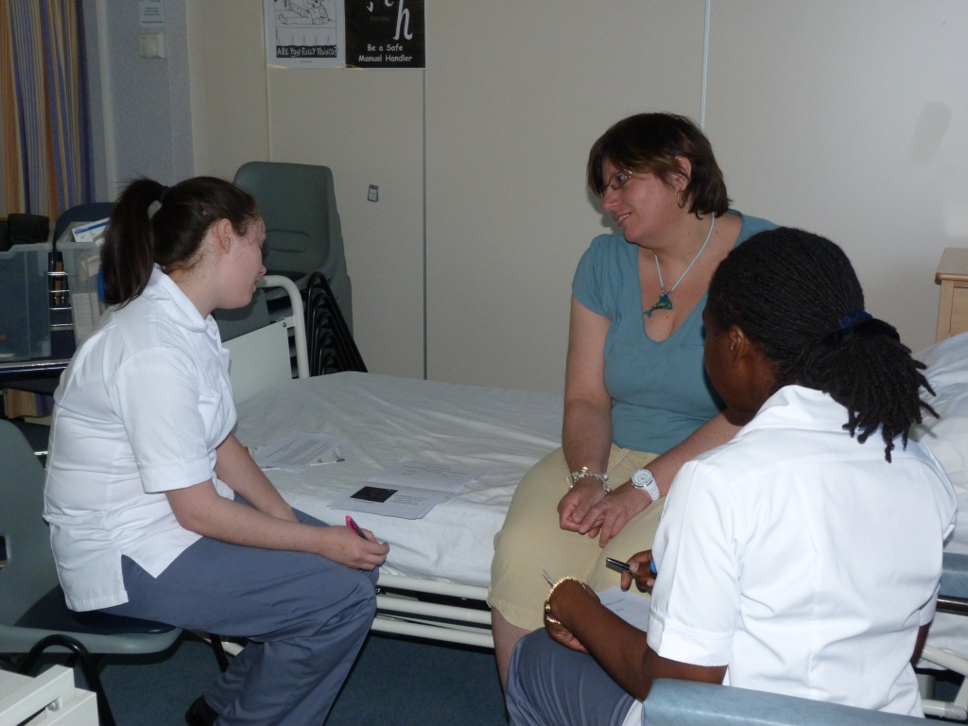
The structure of a Simulated Hospital Admission is fairly simple. A small group of about 10 students begins the day with 1.5 hours of preparation, which comprises discussion of the nature of learning disability, evidence of unmet healthcare need, an introduction to potential reasonable adjustments and a review of the brief for the day. Co-teachers then arrive (n = 5+), and about an hour is spent over sharing refreshments and ice-breaking exercises designed to promote relationships. Following this, students are required to seek the consent of their co-teacher for the proposed activities using a bespoke easy-read consent form; subject to receipt of this, the “patient” is then “admitted” to the ward by means of completing a locally produced healthcare passport and taking basic observations. Students are encouraged to use a range of adaptive communication tools, including the Hospital Communication Book (Clear Communication People 2013).
The day ends with a shared reflection between the co-teachers and students. All are offered the opportunity to comment on whether they enjoyed the experience, identify what they had learned and to indicate the session’s strengths and areas for improvement.

appendix 2: questionnaire
The following questions comprised the Bristol Online Survey used in the project:

1. When did you take part in the Simulated Hospital Admission?
2. Which campus did the simulation take place on?
3. Please describe your experience of the simulated hospital admission conducted by a LOUD co-teacher.
4. What worked well in the Simulated Hospital Admission you took part in?
5. What could have been improved?
6. What skills did you gain from the Simulated Hospital Admission?
7. What helped you to build a relationship with your co-teacher (and, where relevant, carer)?
8. What do you feel were the mutual benefits (for yourselves, co-teachers, carers and lecturers) of taking part in the Simulated Hospital Admission?
9. What challenges did you face during the Simulated Hospital Admission?
10. How did you respond to these?
11. In what ways has the Simulated Hospital Admission helped your learning as a nursing student?
12. What was memorable about the experience of the Simulated Hospital Admission?
13. How has your practice developed as the result of taking part in the Simulated Hospital Admission?
14. Thinking about the future, what would improve working with co-teachers from LOUD during the Simulated Hospital Admission?
15. Please identify your gender.
16. I wish to withdraw from this study. In doing so my responses will not be included.

