



Programme title text   
to be placed here

Faculty of <faculty>

School of <school>

**Canterbury**

[i-zone@canterbury.ac.uk](mailto:i-zone@canterbury.ac.uk)

01227 782222

**DELETE WHERE APPROPRIATE**

**BROADSTAIRS**

[i-zonebroadstairs@canterbury.ac.uk](mailto:i-zonebroadstairs@canterbury.ac.uk)

01843 609888

**If you find that you have any queries after reading this guide, please contact either your Program­me Director (for programme specific queries) or the i-zone for any other queries:**

This handbook sets out a range of information and, where applicable, points to a number of other important documents to help support you through your studies at the University.

The purpose of this handbook is to provide information about your programme of study. This should be read in conjunction with ‘[My Essential Information’](http://www.canterbury.ac.uk/quality-and-standards-office/docs/my-essential-guide-booklet.pdf), which sets out general information relevant to all students at the University.

This information is designed to support you throughout your studies and it is important to familiarise yourself with all the contents of both this handbook and ‘[My Essential Information’](http://www.canterbury.ac.uk/quality-and-standards-office/docs/my-essential-guide-booklet.pdf).

**Your**

**Programme**

**Handbook**

If you have any suggestions for how this handbook may be improved for future students,   
please email your suggestion to: [quality@canterbury.ac.uk](mailto:quality@canterbury.ac.uk)

**MEDWAY**

[i-zonemedway@canterbury.ac.uk](mailto:i-zonemedway@canterbury.ac.uk)

01634 894444

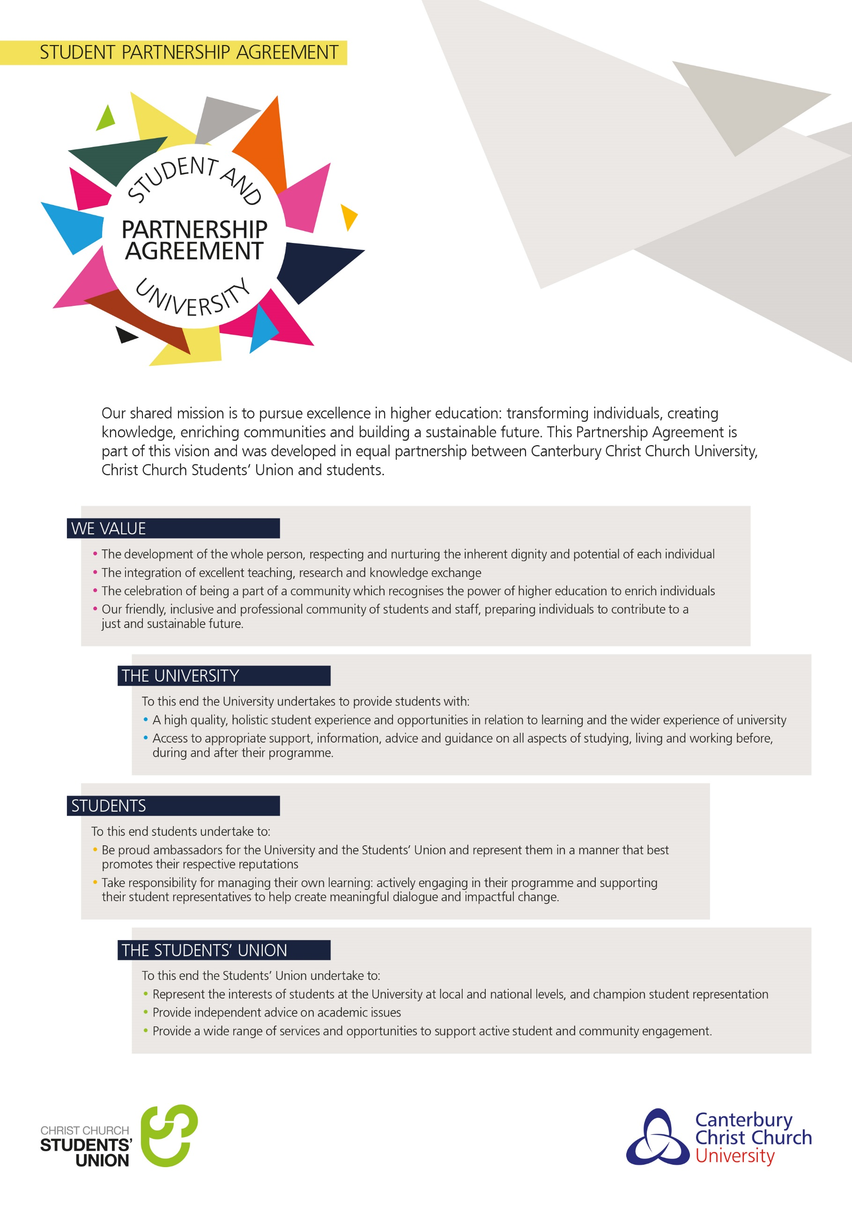

**Table of Contents**

**Type chapter title (level 1)1**

Type chapter title (level 2)2

Type chapter title (level 3)3

**Type chapter title (level 1)4**

Type chapter title (level 2)5

Type chapter title (level 3)6

This template provides a series of headings that are required as part of the Student Programme Handbook. Suggested areas are provided under each heading but these should be interpreted as minimum requirements only. Programme Directors are free to add additional information, where relevant.

Much of the information can and should be taken from the Programme Specification as approved at validation, however there is no longer a requirement for Part One of the Programme Specification to be included in the Handbook. Rather the Part Ones will be published on the University website and a link should be provided to this as part of the Programme Overview.

Please do not reproduce in this handbook any information that is subject to review, such as entire copies, sections or paraphrased versions of University policies, procedures and guidance. Instead wherever possible include a hyperlink to the relevant web document, to ensure students view the correct versions. Please check web links for currency each year to make sure they are still active.

For programmes delivered solely at collaborative partners, an alternative picture may be used for the front page of the handbook and the partner’s logo may be added. All other information should remain identical to the front cover provided as part of the template including the Canterbury Christ Church University logo.

**DELETE THIS BOX**

**Welcome from the**

**Programme Director**

<insert a short welcome to the programme from the Programme Director>

# programme overview

<To include:

* Programme duration and modes of study
* Language of study, where not English
* Programme aims
* Programme learning outcomes
* Professional body accreditation (where applicable)
* Programme structure diagram (to include stepping off points for alternative exit awards)
* Web link to Part One of the Programme Specification>

# Key STAFF AND CONTACT DETAILS

<insert key programme staff contacts (name, telephone number, e-mail address) for: programme director, administrator, and personal academic tutors>

# Key Dates and Timetabling

<insert semester / term dates, examination period, and reassessment period etc. - for undergraduate programmes delivered in line with the revised academic year structure, the official university calendar can be copied and pasted from the University website>

<include information on how a student accesses their timetable – the following standard text could be used, where relevant>

ONLY APPLICABLE FOR PROGRAMMES TAUGHT ON CAMPUS AT THE UNIVERSITY – please delete semester or term as appropriate for your programme

A student’s timetable at Canterbury Christ Church University is typically made up of the following for each module that they study:

* lectures which are attended by everyone studying the module
* seminars and other classes or practicals which are taught in smaller groups
* supporting activities such as inductions of skills sessions.

**Accessing your timetable**

There are a number of ways to keep track of where and when your lectures, seminars, practicals and other programme-related activities are due to take place.

* **Individual Student Timetables (ISTs)**

The majority of students have access to an online personalised timetable (usually referred to as an Individual Student Timetable or ‘IST’), which tells them where and when their classes are due to take place. If you have an IST, you can access it via the ‘My Calendar’ tile in Portal or the calendar that comes with your University email account. ISTs are usually updated twice a year; just before the new academic year starts and just before the Christmas break; the only exception being new students in their first semester / term, for whom ISTs will usually only become available once everyone has registered and (where relevant) picked their optional modules.

* **On Time**

Students can also view the full timetable for the Programme(s) they are studying – and any other Programmes running at Canterbury, Broadstairs or Medway campus – via [OnTime](https://ontime.canterbury.ac.uk/), [CCCU’s online timetabling and rooming system](https://ontime.canterbury.ac.uk/).

For more information about ISTs and OnTime, including full guides and video tutorials, visit the [Student Timetables](https://www.canterbury.ac.uk/students/academic-services/student-timetables.aspx) page of the website.

* **Blackboard**

Your Programme team may also post timetabling information on the Blackboard virtual learning environment. Additionally, they might ‘invite’ you to other activities via your University email account, so you should check that and your CCCU calendar regularly.

Canterbury Christ Church University is committed to publishing a fully-roomed academic timetable before the start of each semester / term, and minimising the number of changes thereafter, in order to help you plan ahead and better manage your work-life balance. Minor amendments to the published timetable may occur due to occurrences outside of the University’s control, so you are advised to check your IST and/or OnTime regularly.

If you are experiencing problems with accessing your timetable, please contact the i-zone.

# Modules

<module outlines may be included in this handbook, or in a separate module guide document which should not replicate this guide>

<include a summary of option choices at all stages of the programme, making it clear how module options are selected. Pre-requisites for option modules must be clearly communicated>

# Teaching and Learning

<explain the programme’s approaches to teaching and learning e.g. the types of teaching and learning activities used by the programme and including highlighting how your VLE sites meet the Digital Learning Thresholds as per expectations in the general ‘My Essential Information’ handbook>

# Assessment

<provide an overview of how students will be assessed>

<include a schedule of assessment deadlines and feedback dates or a link to where students can find this information – please note that [‘My Essential Information’](http://www.canterbury.ac.uk/quality-and-standards-office/docs/my-essential-guide-booklet.pdf) provides details of the Timely Feedback Policy so please clarify if your programme has gained exemption from this policy >

<include guidance on academic referencing>

<insert where and how work should be submitted e.g. through a Turnitin assignment point located on Blackboard or to a designated office, highlighting the University requirement for paperless submission of work where possible>

<adapt the recommended Turnitin set up below as appropriate for your programme>

You can **self-check at least one draft** per assessment in the Blackboard area:

<**insert Blackboard section / specific folder name here**>

Final submissions to Turnitin for marking **up until the due date** will be made in the separate Blackboard area:

<**insert Blackboard section / specific folder name here**>

Final submissions to Turnitin for marking **after the due date**, including where there are extenuating circumstances or a negotiated learning plan, will be made in the separate Blackboard area:

<**insert Blackboard section / specific folder name here**>

Contact your tutor if you have any questions about what, when or where to submit your assessments.

<include the assessment criteria or a link to where students will find this>

# Tutorials / Personal Academic Tutoring

<insert tutorial availability and information about personal academic tutoring>

# Regulatory arrangements

This programme operates within the Regulation and Credit Framework for the Conferment of Awards which provides the regulatory arrangements for the University’s programmes. This sets out information such as how your degree classification will be calculated and the requirements for obtaining your award. You can access it here: [www.canterbury.ac.uk/handbook/policies-procedures](http://www.canterbury.ac.uk/handbook/policies-procedures)

<if a Scheme (e.g. General Modular Scheme) or Special Regulations have been formally approved for this programme, please add a [hyperlink](http://www.canterbury.ac.uk/support/quality-and-standards-office/policies/special-regulations.asp) link to them here. Special regulations identify specific requirements within named programmes in cases where the programme has additional requirements beyond the governing Regulations (for example entry requirements)>

# External Examiner

The University appoints External Examiners to act as an independent check upon the academic standards of each programme. The details of the External Examiner(s) for this programme are given below.

Name of current External Examiner: <insert name of current external examiner>

Position of current External Examiner: <insert position of current external examiner>

Institution of current External Examiner:<insert institution of current external examiner>

In due course, you may be asked to meet the External Examiner(s). This meeting will be to enable the External Examiner to gather information on the quality and standards of the programme. Individual performance will not be assessed at this meeting. You should not, therefore, raise any issues regarding individual assessment outcomes with the External Examiner at this time. If you wish to make an academic or fitness-to practice appeal you should do so through the University's Academic or Fitness-to-Practice Appeals Process, details of which are provided in [‘My Essential Information’](http://www.canterbury.ac.uk/quality-and-standards-office/docs/my-essential-guide-booklet.pdf). If you wish to make a complaint about the quality of your programme you should do so through the University’s Student Complaints Process, details of which are provided in [‘My Essential Information’](http://www.canterbury.ac.uk/quality-and-standards-office/docs/my-essential-guide-booklet.pdf). In line with the Quality Assurance Agency UK Quality Code for Higher Education you should not make direct contact with the External Examiner(s).

The External Examiner for your programme will submit an annual report. All External Examiner reports can be accessed via the Student Portal. You can participate in the formal process through which External Examiner reports are considered and responded to through the programme’s student-staff liaison committee. Details of these meetings will be available from the Programme Director. The response to the External Examiner report will also be made available on the Student Portal.

# Additional information

<you are welcome to include additional information which is not included in this template; simply replace the heading above with your desired heading(s)>

**You may wish to cover:**

Any applicable Professional Body relationship and requirement

Any applicable Fitness to Practice or equivalent policy

Partner details, where appropriate

Placement requirements/opportunities, where appropriate

Study Abroad, Erasmus or Exchange opportunities, where appropriate

Specific academic referencing guidance

Academic essay writing guidance

Examples of how student feedback has informed the programme’s development

Programme specific learning resources guide

The above list is not an exhaustive list and additional information may be added.

Please note that students should **NOT** be provided with multiple Programme Handbooks. This template has been designed to enable all of the necessary information to be included within the one document and as indicated above additional sections can be added to this handbook. The only possible exception to this rule is where a Programme Handbook is provided by the University and a collaborative partner provides a more localised handbook providing additional information specifically about the programme delivery at the collaborative partner.

**DELETE THIS TEXT**